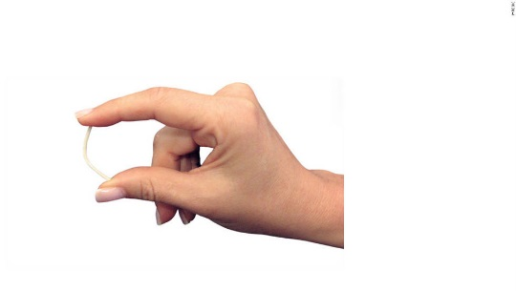  Highlights:  - A matchstick-sized plastic tube that is inserted by a medical provider in the upper arm to prevent pregnancy  - Safe, very effective, and convenient  - Lasts up to 3 years  - Must be inserted and removed by a medical provider  Remember:  - Does not prevent HIV or other sexually transmitted infections (STIs). Protect yourself and others by also using condoms. | Fact Sheet:  Birth Control Implant (Nexplanon®) | MRN:  Name:  D.O.B.:
 | What is the implant (Nexplanon®)?
The birth control implant (Nexplanon®) is a small flexible tube that is placed under the skin of the upper arm by a medical provider. You can feel it when you touch the area with your fingertips, but it’s usually not visible.
The implant contains a hormone that is slowly released into the body. The hormone stops the ovaries from releasing an egg. You can't get pregnant if an egg is not released.
It works for up to 3 years, but can be removed at any time by a medical provider. Once the implant is removed, you may be able to become pregnant immediately. The implant won’t affect your ability to get pregnant in the future.
 | How do you use the implant (Nexplanon®)?
A medical provider will inject a numbing medicine in the area where the implant will be inserted and will put the implant under your skin. The whole procedure takes about 5-10 minutes.
After the implant is inserted, the medical provider will cover the skin with a bandage.

After getting the implant, use condoms or do not have vaginal sex for at least the first 7 days. If you don’t use a condom or it breaks, seek emergency contraception (EC).
You can choose to have the implant removed at any time. If you would like it taken out, return to the clinic. The provider will numb the skin, make a tiny cut, and take it out. Do not try to remove it yourself.
 | What are the benefits of using the implant (Nexplanon®)?
The implant is very effective. No method of birth control is 100% effective, but the implant is more than 99% effective. It is one of the most effective birth control methods available.
It is convenient. There is no medicine to take every day or every week.
It is private. No one will be able to see it.
It works for up to 3 years. If you want to continue using the implant after 3 years, the implant can be replaced with a new one.
 | What are the possible disadvantages of using the implant (Nexplanon®)?
You may have a bruise where the implant is placed in your arm. The bruise will not last long.
You may have a small scar where the implant is put in.
Most women who use the implant notice changes in their periods, especially in the first 6-12 months. After 1 year, most women get fewer or lighter periods. Some women have spotting (bleeding between periods) or longer, heavier periods. This change in bleeding is not harmful.
Some women using the implant may have acne, minor weight changes, or changes in mood.
 | Important! Learn these warning signs.
Although serious problems from using the implant are very rare, there are warning signs of more serious problems that need to be checked right away. Call or come to the clinic immediately if you experience any of these signs. If the clinic is not open, go to the nearest emergency room.
- The skin around the implant gets red, feels hot, or swells, or fluid drains from the skin.
- You can't feel the implant with your fingertips when you touch the area where it was inserted.
Patient Acknowledgment: I have read this fact sheet and understand the information given to me about the implant (Nexplanon®). I understand that I will need a pregnancy test today before receiving the implant. I understand it is my responsibility to follow the instructions on this fact sheet. No guarantee has been made to me as to the results of using the implant. I understand that neither the provider nor the school clinic are in any way responsible should I become pregnant. If I do not get my period within 1 month of starting the implant, I will come back for a pregnancy test. I have been given the chance to ask questions about birth control and the implant in particular. My questions have been answered to my satisfaction.

Patient Signature: _______________________________________________________________ Date: _____/ _____/ _____ Updated 3/2017

