NON-PRESCRIPTION BIRTH CONTROL METHODS

Method | How well does it work? | How to Use | Pros | Cons
Male Condom  (Latex or Polyurethane)  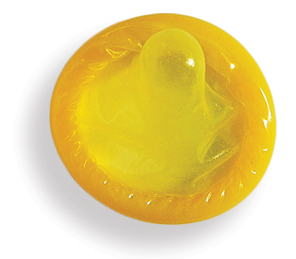 | 82% | Use a new condom each time you have sex  After sex, pull out before penis gets soft while holding onto the condom’s rim  Use a polyurethane condom if you are allergic to latex | Can buy at many stores  Can put on as part of sex play/foreplay  Can help prevent early ejaculation  Can be used for vaginal, oral, and anal sex  Protects against HIV and many other sexually transmitted infections (STIs)  Can be used while breastfeeding | Can decrease sensation  Can cause loss of erection  Can break or slip off
Female/Internal Condom (Polyurethane)  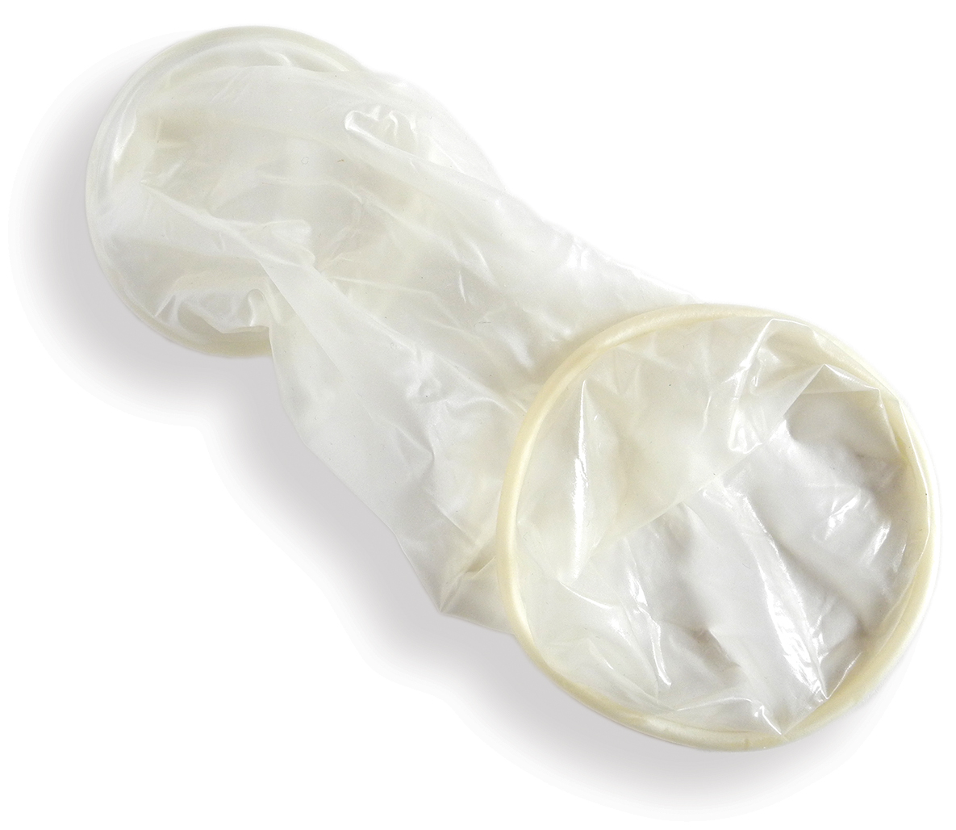 | 79% | Use a new condom each time you have sex  Use lubrication as needed | Can buy at many stores  Can put in as part of sex play/foreplay  Can be used for anal and vaginal sex  May increase pleasure when used for vaginal sex  Good for people with latex allergy  Protects against HIV and other STIs  Can be used while breastfeeding | Can decrease sensation  May be noisy  May be hard to insert  May slip out of place during sex
Spermicide  Cream, gel, sponge, foam, inserts, film  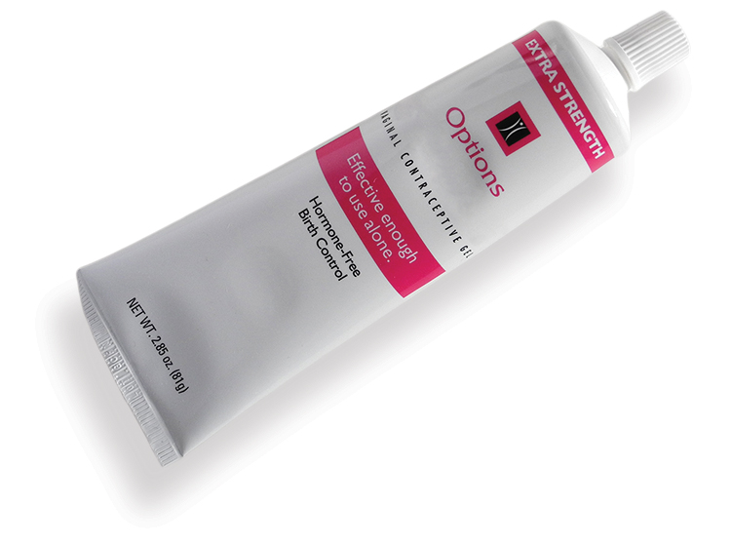 | 72% | Insert spermicide each time you have sex  Insert spermicide deep into vagina shortly before sex  May use with condoms (to protect against HIV and STIs) | Can buy at many stores  Can insert as part of sex play/foreplay  Comes in many forms  Can be used while breastfeeding | May raise the risk of getting HIV or other STIs  May irritate vagina or penis  Cream, gel, and foam can be messy  Does not protect against HIV or other STIs
Withdrawal  Pull-out | 78% | Pull penis out of vagina before ejaculation (that is, before coming) | Costs nothing  Can be used while breastfeeding | Less pleasure for some  Doesn’t work if penis is not pulled out in time  Does not protect against HIV or other STIs  Must interrupt sex
Fertility Awareness  Natural Family Planning  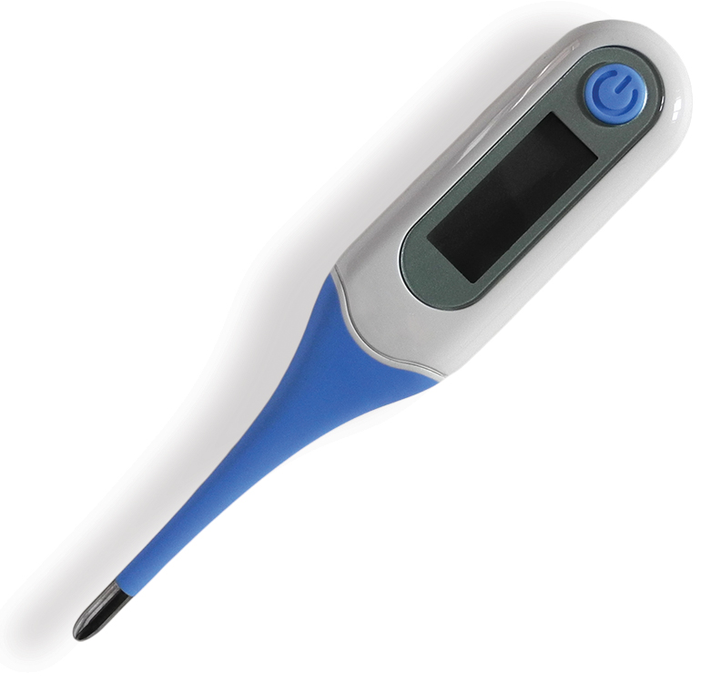 | 76% | Predict fertile days by:  - taking temperature daily  - checking vaginal mucus for changes; AND/OR  - keeping a record of your periods  It works best if you use more than one of these  Avoid sex or use condoms/spermicide during fertile days  For full instructions:  http://www.americanpregnancy.org/preventingpregnancy/  fertilityawarenessNFP.html | Costs little  Can be used while breastfeeding  Can help with avoiding or trying to become pregnant | Must use another method during fertile days  Works best if you have regular cycles  Many things to remember with this method  Does not protect against HIV or other STIs
Breastfeeding  (No Periods)  Lactation Amenorrhea Method (LAM)   | 95% | Nurse at least every  4 hours during the day  Nurse at least every 6 hours during the night  Must breastfeed only—  no bottles, formula, or food  Works only until:  - You get your first period  OR  - 6 months after childbirth (whichever comes first) | Costs nothing | Must breastfeed only: can’t use formula or baby food  Must breastfeed often  Does not protect against HIV or other STIs
Emergency Contraception Pills  Progestin EC (Plan B One-Step® and others) and ulipristal acetate EC (ella®)  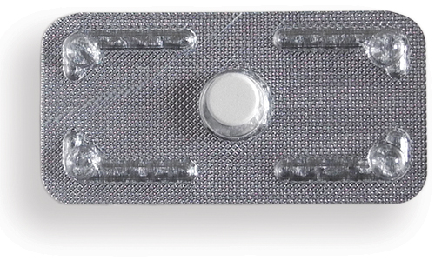 | 58%  Ulipristal acetate EC works better than progestin EC if you are overweight  Ulipristal acetate EC works better than progestin EC in the 2-5 days after sex | Works best the sooner you take it after unprotected sex  You can take EC up to 5 days after unprotected sex  If pack contains 2 pills, take both together | Can be used while breastfeeding  Available at pharmacies, health centers, or health care providers: Call ahead to see if they have it  You can get some brands without a prescription | May cause stomach upset or nausea  The next period may come early or late  May cause spotting  Does not protect against HIV or other STIs  Ulipristal acetate EC is only available with a prescription  People under age 17 need a prescription for some brands  May cost a lot

