Thinking About Getting Pregnant?
Key steps for a healthy pregnancy

Healthy Body for a Healthy Baby
- Pregnancy is wonderful, but it can be tough on your body. Your baby relies on you for all it needs to grow. You must build up your nutrition stores to get ready for a healthy pregnancy.
  - Fruits and vegetables keep you healthy. Make sure to eat plenty of these! Eat at least 5 servings of fruits and vegetables each day.
  - A daily prenatal vitamin helps prevent birth defects. Start taking one before you try to conceive, and continue while pregnant and while nursing.
- Getting to a healthy weight before pregnancy and daily exercise help to keep you and your baby healthy.
  - Talk to your clinician about foods to avoid during pregnancy.
  - Ask how much weight you should gain during pregnancy.
- Review your family health history with your clinician. If there are birth defects in your family or your partner’s family, you may want tests before or during pregnancy.

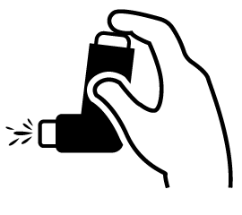 | Common Health Problems  - Many health problems (such as diabetes, high blood pressure, asthma, and anemia) require special care before and during pregnancy.  - Health problems that are not well controlled can make you and your baby sick.  - Some medications can harm a fetus. You may need to switch these before you get pregnant.  - If you have any health problems, see your clinician before pregnancy. You can manage your health problems to keep yourself and your baby healthy.
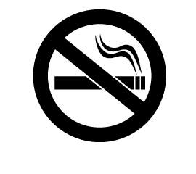 | Smoking, Alcohol, and Drugs  - Alcohol, cigarettes, and other drugs can cause birth defects.  - If you need to quit smoking, drinking, or using drugs, ask your clinician for help.
Toxic Exposures
- Toxins can harm you and your baby.
- Avoid lead, carbon monoxide, radiation, cigarette smoke, pesticides, and dry cleaning solvents.
- Don’t put hot food or drinks in plastic containers.
- If you live with a person who works around toxins, ask him/her to change out of work clothes before coming near you.

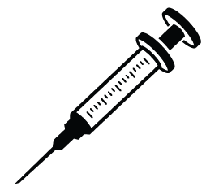 | Vaccines and Germs  - Vaccines protect you and your baby from germs. Some of these germs cause birth defects.  - Before pregnancy, ask your clinician if your vaccines are up to date.  - The flu poses a big threat to pregnant women. Get a flu shot to protect yourself and your baby.  - Stay away from cat feces. Have someone else clean the kitty litter.  - Zika virus, which is spread by mosquitos and through sex, causes severe birth defects. Avoid travel to places with Zika.  - Wash your hands more often. Germs that don’t usually harm adults can cause severe birth defects.
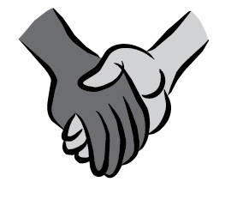 | Safety and Support  - You may feel worried at times as you prepare for a new baby.  - Get the support you need for a safe, healthy pregnancy. Family and friends can help.  - If there is fear or abuse in your life, you can get help. Talk to your clinician about your options.
Male Partners
- Male partners should limit alcohol, quit smoking or drug use, eat healthy foods, and lower stress.
- Men who drink a lot, smoke, or use drugs can have problems with their sperm. This may cause you to have trouble getting pregnant.
- If your partner won't quit smoking, it would be better if he should not smoke near you or inside your home.

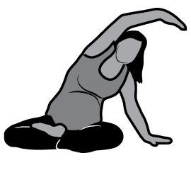 | Exercise  - If you do not exercise, consider starting a program of stretching, yoga, walking, and/or gentle aerobics.  - Try to exercise at least 30 minutes a day, 5 times a week.

