Birth Control Across the Gender Spectrum

Can you get pregnant?
If you have a uterus and ovaries, you can get pregnant. This is true even if you take testosterone. Although it may stop your monthly bleeding, testosterone does not keep you from getting pregnant.

Can you get someone pregnant?
If you have a penis and testes, you can get someone pregnant. This is true even if you take estrogen. Estrogen may lower your sperm count, but it does not keep you from getting someone pregnant.

Birth control for people taking testosterone
There are several birth control options for people who have a uterus and ovaries and who take testosterone. The progestin pill, implant, IUD, and shot may help decrease monthly bleeding. Some people use one of these methods just to control bleeding, even if they don’t need birth control. Progestin does not interact with testosterone. The copper IUD prevents pregnancy and contains no hormones. Condoms prevent pregnancy and sexually transmitted infections (STIs).

Birth control for people taking estrogen
People who have a penis and testes and who take estrogen can choose any birth control method.

Permanent Options
Permanent methods are great for people who don’t ever want to get pregnant. These include tubal ligation, Essure, hysterectomy, orchiectomy, and vasectomy.

Don’t forget about sexually transmitted infections!
Condoms can prevent human immunodeficiency virus (HIV) and other STIs. There are two types of condoms, internal and external. Both types help to prevent pregnancy and infections.

Birth Control Choices Across the Gender Spectrum
Method | How well does it work? | How to Use | Pros | Cons
The Implant  Nexplanon®  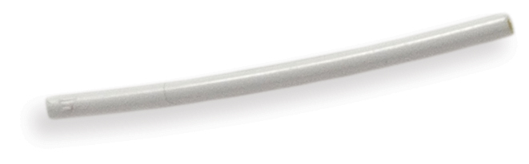 | > 99% | A health care provider places it under the skin of the upper arm.  It must be removed by a health care provider. | It may last up to 5 years.  It often decreases cramps.  After 1 year, you may have no monthly bleeding at all.  It may lower the risk of uterine lining cancer, ovarian cancer, and polycystic ovary syndrome (PCOS). | May cause spotting  It may cause mood changes.
Progestin IUD  Liletta®, Mirena®, Skyla®, and others  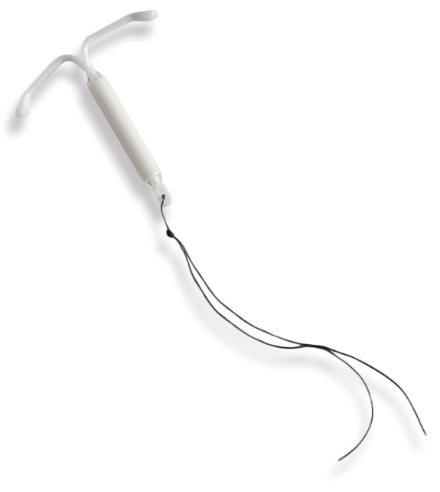 | > 99% | A health care provider places it in the uterus.  It is usually removed by a health care provider. | It works for 3 to 7 years, depending on which IUD you choose.  It may improve monthly bleeding and cramps.  After 1 year, you may have no monthly bleeding at all.  It may lower the risk of uterine lining cancer, ovarian cancer, and polycystic ovary syndrome (PCOS). | May cause spotting
Copper IUD  ParaGard®  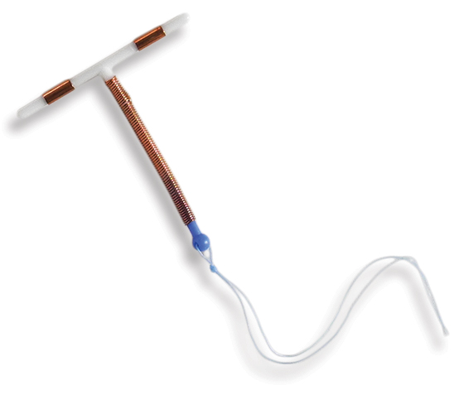 | > 99% | A health care provider places it in the uterus.  It is usually removed by a health care provider. | May be left in place for up to 12 years | May cause spotting (if you are taking testosterone, this may not be an issue for you).
The Shot  Depo-Provera®  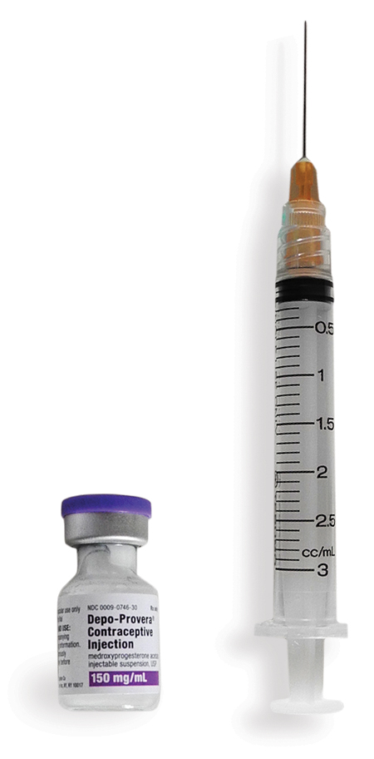 | 94% | Get a shot every 3 months.  You can get the shot at a health care office, or you can give yourself the shot. | Each shot works for 12 weeks.  It usually decreases monthly bleeding.  After 1 year, you may have no monthly bleeding at all.  It may lower the risk of uterine lining cancer, ovarian cancer, and polycystic ovary syndrome (PCOS). | It may cause spotting, weight gain, depression, hair or skin changes, or change in sex drive.  It may cause delay in getting pregnant after you stop the shots.  Side effects may last up to 6 months after you stop the shots.
Progestin-Only Pills  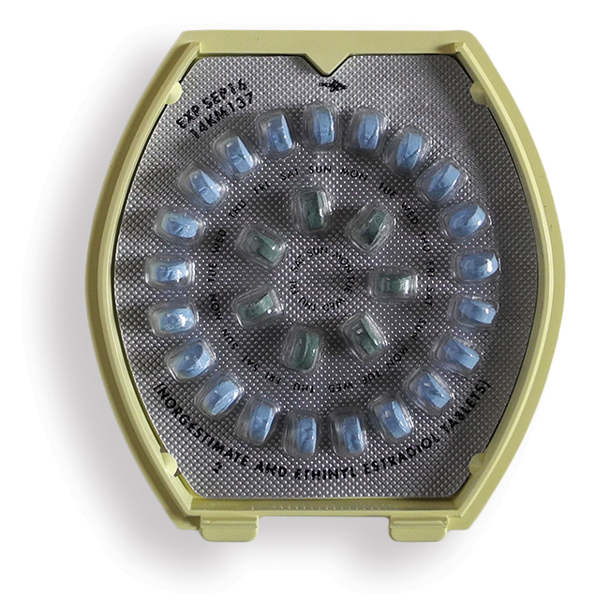 Camila, Nor-QD®  Micronor | 91% | You must take the pill at the same time daily. | It’s easy to use.  It may lower the risk of uterine lining cancer, ovarian cancer, and polycystic ovary syndrome (PCOS). | It often causes spotting, which may last for many months.  It may cause depression, hair or skin changes, or change in sex drive.
External Condom  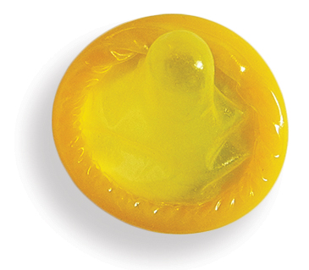 | 82% | Use a new condom each time you have sex  Use a polyurethane condom if allergic to latex | Can buy at many stores  Can put on as part of sex play/foreplay  Can help prevent early ejaculation  Can be used for oral, vaginal, and anal sex | Can decrease sensation  Can cause loss of erection  Can break or slip off
Internal  Condom   | 79% | Use a new condom each time you have sex  Use lubrication as needed | Can put in as part of sex play/foreplay  Can be used for anal and vaginal sex  May increase pleasure  Good for people with latex allergy | Can decrease sensation  May be noisy  May be hard to insert  May slip out of place during sex
Withdrawal  Pull-out | 78% | Pull penis out of vagina before ejaculation (that is, before coming) | Costs nothing | Less pleasure for some  Does not work if penis is not pulled out in time  Must interrupt sex
Diaphragm  Caya® and Milex®  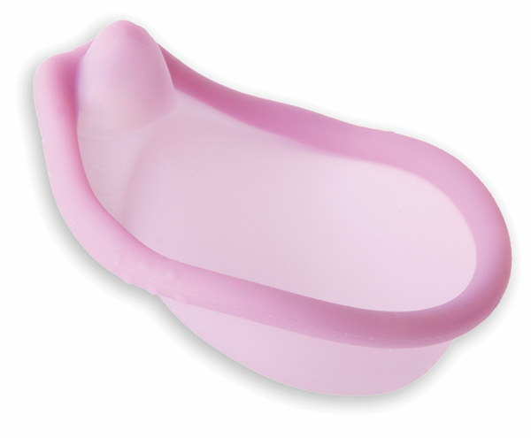 | 88% | Must be used each time you have sex  Must be used with spermicide | Can last several years  Costs very little to use  May protect against some infections, but not HIV | Using spermicide may raise the risk of getting HIV  Should not be used with vaginal bleeding or infection  Raises risk of bladder infection
Spermicide  Cream, gel, sponge,  foam, inserts, film  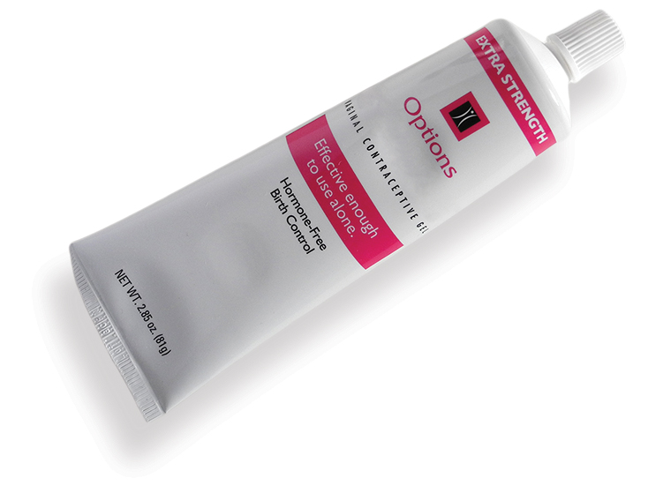 | 72% | Insert spermicide each time you have sex | Can buy at many stores  Can insert as part of sex play/foreplay  Comes in many forms: cream, gel, sponge, foam, inserts, film | May raise the risk of getting HIV  May irritate vagina, penis  Cream, gel, and foam can be messy
Emergency Contraception Pills  Progestin EC (Plan B One-Step®and others) and ulipristal acetate (ella®)  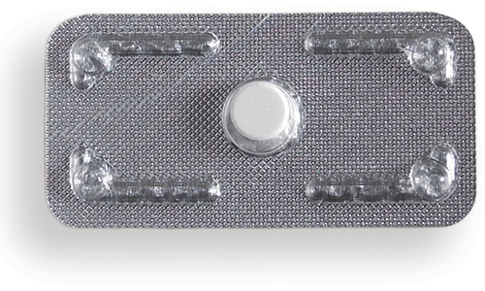 | 58-94%  Ulipristal acetate EC works better than progestin EC if you are overweight  Ulipristal acetate EC works better than progestin EC in the 2-5 days after sex | Works best the sooner you take it after unprotected sex  You can take EC up to 5 days after unprotected sex  If pack contains 2 pills, take both together | Available at pharmacies, health centers, or health care providers: call ahead to see if they have it  People of any age can get progestin EC without a prescription, and it doesn’t interact with testosterone. | May cause stomach upset or nausea  Your next monthly bleeding may come early or late  May cause spotting  Ulipristal acetate EC requires a prescription, and we don’t know whether or not it interacts with testosterone.  May cost a lot
Remember, these methods do not protect against human immunodeficiency virus (HIV) or other sexually transmitted infections (STIs). Always use condoms to protect yourself!

