Sam’s Medication Abortion Learning Guide

Through RHAP’s new comic Sam’s Medication Abortion, we follow one person’s experience of having an abortion using pills. We see Sam’s experience of taking the medication, the side effects, and their feelings after. To learn more about medication abortion, check out some of RHAPs resources that you can download for free from our website reproductiveaccess.org.

Resources
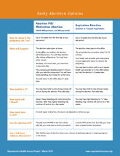
Early Abortion Options
Sam chose to use medication for their abortion, but some may choose to get an abortion procedure. You can learn more about those two options, their side effects, and pros and cons with this sheet.

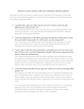
Medication Abortion FAQs
Sam was able to reference different materials and ask a friend questions when they decided to have an abortion. RHAP has an FAQ sheet that may be helpful in answering questions that might come up when someone is using pills for an abortion.

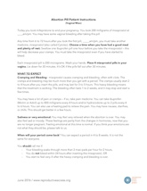
Medication Abortion Aftercare Instructions (Vaginal Miso)
This sheet gives you step-by-step info about what to do and what to expect when you are using pills for your abortion. This sheet explains what happens for people who decide to insert the misoprostol into their vaginas, like what was depicted in Sam’s story.

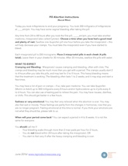
Medication Abortion Aftercare Instructions (Buccal Miso)
This sheet gives you step-by-step info about what to do and what to expect when you are using pills for your abortion. This sheet explains what happens for people who decide to put the misoprostol pills in their cheeks (known as buccally).

Protocol for Medication Abortion Using Misoprostol Alone
For some it may be hard to find mifepristone pills. Using misoprostol pills alone to end a pregnancy is an option. This page links to websites that have protocols for medication abortion using misoprostol only.

