**Early Pregnancy Loss Management Workshop**

**Case Studies Facilitator’s Guide**

This presentation is designed to be interactive. The cases should be printed in their entirety, including the appendices which can be referenced by the learners throughout this activity. In this facilitator’s guide, the cases are included below along with the answers (in italics) for each section. Be sure to refer to the appendices (algorithm and classification tables) when indicated for each step of the cases. These can be found at the end of this facilitator's guide, the end of the learners document, as well as in the PowerPoint slides. The PowerPoint slides can be printed out to use as handouts as needed.

**Case # 1: “Melissa” (she/her) Pregnancy of unknown location → Complete early pregnancy loss**

You are the on-call clinician at night for your practice. You receive a call at 6 am from Melissa, who reports she is early in pregnancy, and has had 3 days of vaginal spotting. She is now calling because she is having more bleeding and clots for the last 2 hours. She is wondering if she needs to go to the emergency room. What additional information do you need?

* *LMP, menstrual history (was LMP typical for her or could it have represented 1st tri bleeding)*
* *OB and pertinent medical history (h/o ectopic, bleeding problems, anemia)*
* *Ask if she had an ultrasound this pregnancy (to confirm an intrauterine pregnancy (IUP))*
* *Assess amount of bleeding; quantify how often changing pad, any symptoms of anemia*
* *Assess for pelvic pain, especially unilateral, lightheadedness/dizziness, referred shoulder pain*
* *Use the first trimester bleeding algorithm throughout this case (see Appendix A)*

Melissatells you she is a 34-year-old woman G4P3003 with no significant medical problems, and her only medication is a prenatal vitamin. Her pregnancy test was first positive 2 weeks ago, after she missed her period. She tells you her LMP was 8 weeks ago. She was seen last week in the office and was scheduled for an ultrasound, but has not had it done yet.

For the last 3 days, she describes a small amount of red blood when wiping each day but without cramping. For the last 2 hours, she has had bleeding heavier than a period, with 2-3 clots the size of golf balls. She has soaked 3 maxi pads in the last 2 hours. She has no history of bleeding problems or anemia, and has no lightheadedness or dizziness. She has mild cramps like menses, but no other pelvic pain. She feels overall well, just worried. What should you tell her?

* *She has no signs or symptoms of acute blood loss, so there is no need to go to emergency room right now*
* *Drink plenty of fluids to stay hydrated*
* *Come to clinic first thing this morning*
* *Give warning signs (for ectopic or blood loss): fever, worsening or lateralizing pelvic pain, lightheadedness, dizziness, or soaking more than 2 pads per hour*

Melissacomes to the office that morning to meet you. She tells you she had about 2 more hours of heavy bleeding but it then slowed down. She is now changing her pad every 4 hours and the cramping has improved. You assess her feelings about the pregnancy and learn that she was trying to get pregnant with her 4th child. Her urine pregnancy test is positive (don’t forget to check this since a negative pregnancy test confirms completed pregnancy loss and saves a lot of worry).

You do an exam which shows:

BP: 108/56, P: 74, R: 16, T= 98.6 Pox: 100%

Speculum: multiparous slightly open cervix, moderate amount of brown and red blood in vaginal vault. No products of conception or large clots are seen.

Bimanual exam: uterus 5-6 weeks size, no uterine or adnexal masses or tenderness

What can we tell Melissaabout what’s going on?

* *She is likely experiencing an early pregnancy loss by history (we call it a pregnancy loss or miscarriage in our conversation with her, not a spontaneous abortion or pregnancy failure). An ectopic pregnancy or an ongoing pregnancy is still a slight possibility. Further testing with an ultrasound and blood work will help us to differentiate between these three diagnoses.*
* *We reassure her that she did not do anything that caused this to happen. We also ask what support she will have at home, and if she wants her partner or another support person to come in during the evaluation.*

What should we do next?

* *Ultrasound (ideally a point of care ultrasound, otherwise she can be sent to radiology)*
* *Labs: hemoglobin, quantitative bHCG. Consider CT/GC screening.*

You do a transvaginal ultrasound. Describe the results.

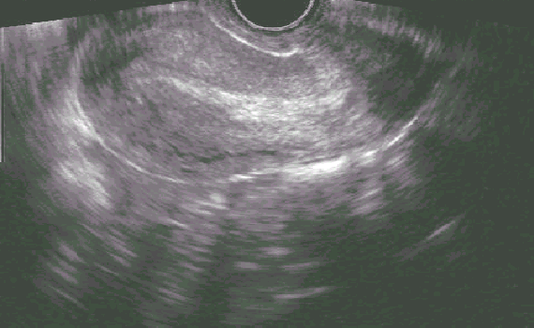

*The ultrasound shows a mildly thickened endometrium. No gestational sac is present.*

*You may inform the learners that no adnexal masses or free fluid are evident.*

What is your differential diagnosis? What will you tell Melissaabout what is going on? Does not seeing any adnexal masses definitively rule out ectopic?

* Review the algorithm in Appendix A – *Likely she has had a completed early pregnancy loss, but we cannot completely rule out ectopic pregnancy or early viable pregnancy since we do not have a prior ultrasound for comparison.*
* *The lack of tenderness on bimanual exam, lack of unilateral pain, and absence of adnexal mass or free fluid on ultrasound is reassuring, and leans us away from ectopic pregnancy. The presence of these would make us more concerned. Note that only about 20-25% of ectopic pregnancies will have a visible mass on ultrasound – a negative ultrasound is not adequate to rule out ectopic.*
* *At this point, a definitive diagnosis of early pregnancy loss could be made if the following had been true: 1) she brought the passed tissue and we identified a gestational sac, 2) products of conception were identified on exam, or 3) she had a prior ultrasound documenting an IUP*.

What is your plan? Are there any other labs you might want to get?

* *If anemic, start iron*
* *Follow serial quantitative beta-HCGs (every 48 hours)*
* *Give ectopic warning signs – dizziness, referred shoulder pain, severe unilateral pelvic pain*

Melissa’sinitial beta-HCG level comes back at 8,150 and 48 hours later it is 1,094. Her hemoglobin is 11.4. What is your diagnosis now?

* You may again review the algorithm in Appendix A – *Likely she has had a completed pregnancy loss, but we still cannot completely rule out ectopic pregnancy since we never saw an IUP.*
* *The drop in beta-HCG excludes viable pregnancy at this point. Although fall of HCG > 50% in 48 hours suggests completed pregnancy loss, most experts agree that a drop of more than 80%, as seen in this case, is needed for diagnostic certainty.*
* *“Spontaneous abortion (SAB)”, “miscarriage”, “early pregnancy failure (EPF)”, and “early pregnancy loss (EPL)” are all terms used to describe this diagnosis. The authors prefer “miscarriage” and “early pregnancy loss” which are more patient-centered terms*.
* Review Appendix B – *terminology of types of early pregnancy loss. Because only an endometrium is seen, it is likely that Melissa**has had a complete pregnancy loss.*

Do we need to follow the quants to zero? How long might they take to get there?

* *Many will say “yes”, since a pregnancy was never seen in the uterus and an ectopic pregnancy was never completely ruled out. The beta-HCG level can drop in an ectopic pregnancy, and the risk of ectopic rupture persists until the beta-HCG is <10.*
* *It would be reasonable to check a beta-HCG once week, then once every other week, until the level is <10. This may take up to 4 weeks.*

Melissaasks when she can start trying to get pregnant again. What should you say?

* *There is no medical reason to delay trying to get pregnant again; the evidence supports that this is safe and does not increase risk of future pregnancy loss. Patients may wish to wait until they are emotionally and physically ready, and can be offered any birth control option.*

If Melissadidn’t want to get pregnant again, when could you insert an IUD, if that was her preference?

* *An IUD can be inserted as soon as the pregnancy loss is confirmed to be complete. She should be counseled that there is a slightly higher risk of expulsion if placed now, so waiting can be her informed decision.*

Learning points for case 1:

1. Early pregnancy loss is not an emergency, and does not warrant referral to the ER, unless there are signs and symptoms of acute blood loss or the history implies ectopic.
2. Ultrasound and bhCG can be used together to confirm a diagnosis when a patient presents with suspected early pregnancy loss. There are cases (such as this one), when the location of the pregnancy cannot be confirmed. These patients need to be followed more closely for ectopic and the bhCG levels should be followed to zero.
3. A fall of beta-HCG levels > 50% in 48 hours suggests a completed pregnancy loss. Most experts agree that a higher drop (>80%) is needed for diagnostic certainty.
4. Other routine labs include Rh blood typing for pregnancies over 8 weeks and hemoglobin (for early pregnancy loss-related care). Clinicians should also consider STD testing and other routine healthcare maintenance.
5. Accurate and comprehensive counseling is crucial. This includes discussing etiology, prognosis for future pregnancies, reassurance, and offering emotional support.

END OF CASE

**Case # 2: “Dee” (they/them) Anembryonic pregnancy**

Dee is here for their first prenatal appointment with their partner, Max. They are a 29-year-old G2P1001 with a history of gallstones but is otherwise healthy. They had an uncomplicated vaginal delivery 3 years ago. Dee tells you they are sure their LMP was 10 weeks ago, but notes that they had been taking birth control on and off for the last few months. They are excited about the pregnancy, as Dee and their partner had been thinking about trying. They had a positive pregnancy test at home and some nausea a few weeks ago which has since resolved. They have not had bleeding, abdominal pain or cramping.

What should you do next?

* *Exam, including bimanual exam*
* *Doppler ultrasound, to detect possible FH, given their gestational age and uncertain LMP due to be on OCPS*

You do an exam, which shows:

BP 114/62, HR 80, RR 12, SO2 99%

They appear comfortable and their abdomen is soft and nontender. There is no palpable fundus on abdominal exam.

Dopplers: No fetal heart rate is heard

Bimanual exam: uterus 6-week size, nontender. Adnexa are without mass and nontender.

What is your assessment? What is your plan?

* Assessment:
  + *Size is less than dates. This could be from:*
    - *Early IUP with dates discordant from LMP due to recent oral contraceptive use or reporting error*
    - *10-week IUP with retroverted uterus or body habitus - difficult to palpate the uterine fundus and hear fetal heart tones*
    - *Ectopic pregnancy*
    - *Early pregnancy loss*
    - *Not pregnant - false positive pregnancy test at home*
* Plan:
  + *Confirm urine pregnancy test is positive*
  + *Do a point of care ultrasound, if available. Otherwise, refer to radiology.*
  + *Quantitative beta-HCG*

The urine pregnancy test is positive. You do a transvaginal ultrasound.

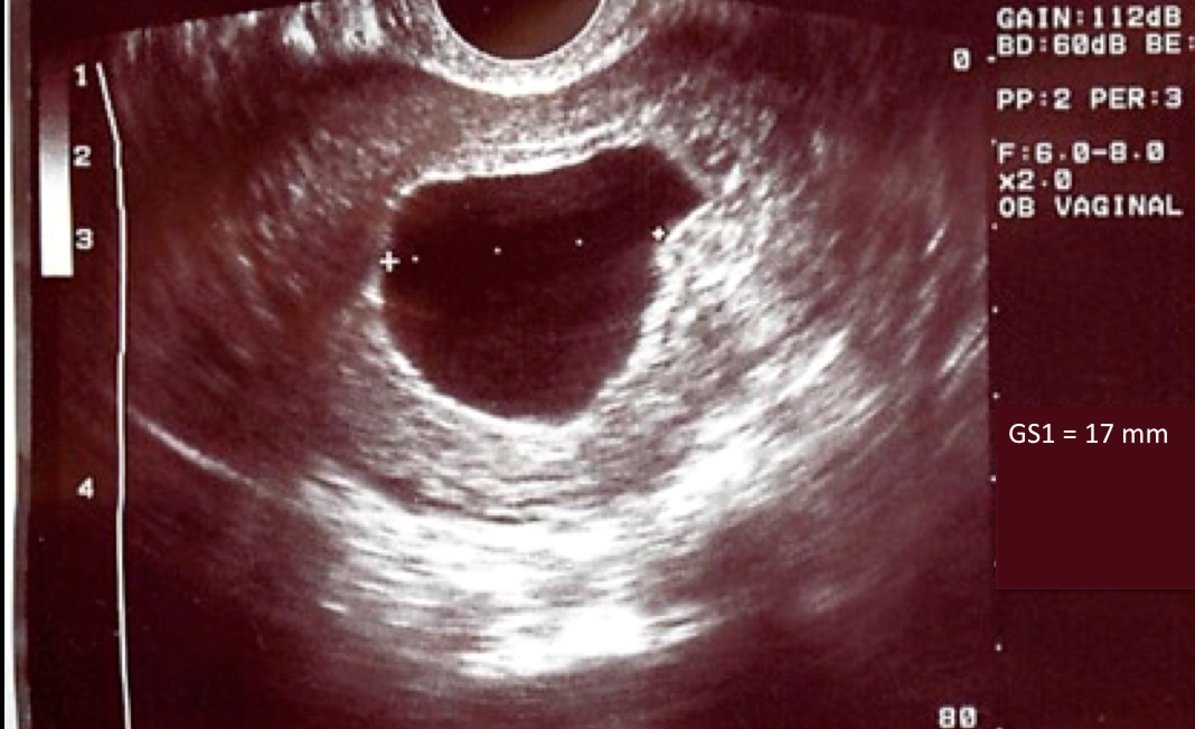

Describe the ultrasound:

* The ultrasound shows:
  + *Intrauterine gestational sac*
  + *The gestational sac measurement is 17mm. For this case, though not listed, the mean sac diameter (MSD) is also 17 mm.*
  + *There is no visible yolk sac or embryonic pole*

How do you interpret this ultrasound result?

* *Suspicious of, but not diagnostic for, early pregnancy loss. There is a small chance that this is an early pregnancy and her menstrual dates were wrong.* 
  + Review the ultrasound diagnostic criteria for early pregnancy loss in Appendix C

What should we do next? How should we counsel Dee and Max?

Next steps:

* *Counsel Dee and Max about likely but not definitive pregnancy loss*
* *Check Rh type (>8 weeks), hemoglobin and quantitative beta-HCG level*
* *Come back in 2 days for repeat beta-HCG*

Counseling should include:

* *Explain that, in the absence of vaginal bleeding, definitive diagnosis of early pregnancy loss will require a repeat ultrasound in 14 days which shows no embryo (see Appendix C).*
* *May repeat an ultrasound earlier, however, to look for an embryo if waiting 14 days is too long. If no embryo is seen, however, Dee will still need a repeat ultrasound 14 days following the first.*
* *Reassure them that if this is an early pregnancy loss it was not caused by anything they did, and that early pregnancy losses are very common, occurring in about 1 out of every 5 pregnancies.*

Dee follows up with you 3 days later. Their initial beta-HCG level was 12,480 and their repeat at 48 hours was 10,560. They have had no new symptoms and overall feel well.

What is your diagnosis? What is your plan?

Assessment:

* *Once the beta-HCG level reaches 5,000 its rate of rise or decline cannot be used to reliably confirm viability or non-viability. At approximately 9-weeks gestation, beat-HCG levels can decline in normal pregnancies. When accompanied by heavy bleeding, however, a decline in beta-HCG levels of >80% suggests completed early pregnancy loss. In this patient, who has not had bleeding, the beat-HCG levels are non-diagnostic and early pregnancy loss and viable pregnancy both continue to be possibilities.*

Plan:

* *Repeat the ultrasound (discuss why, and discuss when – based on the table in Appendix C).* 
  + *For definitive diagnosis using ultrasound criteria, you would need to wait 14 days to confirm early pregnancy loss.*
  + *The patient may not wish to wait the full 14 days before repeating the ultrasound and it is reasonable to repeat it at 7 days.*
  + *Also note that if this were an undesired pregnancy, she could be referred for termination of pregnancy, even if the viability of the pregnancy is still unknown*.

Dee opts to repeat the ultrasound in 14 days to be 100% sure. The ultrasound shows the same large sac and still no fetal pole or yolk sac. What is your diagnosis? What is your plan?

Assessment:

* *Confirmed early pregnancy failure* (based on criteria in Appendix C)

Plan:

* *Discuss early pregnancy loss management options. Patient-friendly handouts describing these options can be found* [*on the RHAP website:*](https://www.reproductiveaccess.org/resources/?rsearch=&rtype%5B%5D=60)
  + [*Early Pregnancy Loss Treatment Options*](https://www.reproductiveaccess.org/resource/miscarriage-treatment-options/)
  + [*Expectant management*](https://www.reproductiveaccess.org/resource/miscarriage-treatment-letting-nature-take-its-course/)
  + [*Medical management*](https://www.reproductiveaccess.org/resource/miscarriage-treatment-medication/) *(with mifepristone and misoprostol or misoprostol alone)*
  + [*Uterine aspiration*](https://www.reproductiveaccess.org/resource/miscarriage-treatment-procedure/)
    - *Manual Vacuum Aspiration can be done using local anesthesia in the office*
    - *If patient desires sedation, they can be referred for procedure with sedation*

Dee decides to pursue expectant management. They want to avoid any extra medications or procedures, if possible. You counsel them on what to expect and provide them with prescriptions for ibuprofen and hydrocodone-acetaminophen 5/300 #4 tabs to help with cramping pain if needed. Dee has a reliable way of contacting you or your colleagues in case they have questions or concerns.

How often does expectant management work?

* *Various studies have examined expectant management. The success rate (measured by complete passage of products of conception) within 4 weeks is approximately 60% with anembryonic pregnancies, 75% with asymptomatic fetal demise, and >90% with incomplete early pregnancy loss. Although most studies measure outcomes at 4 weeks or less, there is no evidence suggesting that a longer waiting period is unsafe in the first trimester.*

What anticipatory guidance do you give Dee regarding when to call?

* *Dee should call if they have a fever or heavy bleeding. Heavy bleeding is quantified as bleeding that soaks through more than 2 pads per hour for two hours in a row. If they call to report this level of bleeding, and they are lightheaded or dizzy, they should be seen right away. If they are otherwise asymptomatic, they can be instructed to stay hydrated, take 800mg ibuprofen, and call back in one hour.*

Two weeks later, they ask to come for a follow up appointment to discuss their options. Dee has not had any heavy bleeding, and only a couple days of light spotting. They are tired of waiting and now want “all this to be over.”

What options would you now offer her?

* *Medical management with mifepristone and misoprostol*
* *Medical management with misoprostol alone (if mifepristone not available)*
* *Uterine aspiration*

Dee decides to take the mifepristone and misoprostol. How do you counsel them to use the medications?

* *Click* [*here*](https://www.reproductiveaccess.org/resource/miscarriage-treatment-medication/) *for a patient-friendly instruction sheet*
* *Using mifepristone in addition to misoprostol is more effective than misoprostol alone. The success rate of completed early pregnancy loss with mifepristone and misoprostol is 84% at 4 days. The success rate using misoprostol alone is 67% at 4 days.*
* *Due to FDA regulations, mifepristone must be dispensed by a certified provider or pharmacy, though it does not need to be dispensed in-person, in-office. Patients could receive mifepristone in the mail or at a certified pharmacy.*
* *Misoprostol with or without mifepristone can be safely used to manage early pregnancy losses up to 12 weeks gestational age based on ultrasound criteria, not LMP. Cramping and bleeding may be heavier between 9-12 weeks gestational age.*
* *After 9 weeks gestational age patients may recognize products of conception in the pregnancy tissue that they pass. Prior to 9 weeks, patients are unlikely to see a fetus. Some patients may want to be prepared for what they may see.*

Dee takes the mifepristone in the office. Twenty-four hours later, at home, they take 600 mg of ibuprofen, and inserts 800 mcg (four 200 mcg tablets) of misoprostol into the vagina. About one hour later they call you because they have a fever to 100.6 and shaking chills and is worried they have an infection.

Why is Dee having these symptoms?

* *Low-grade fever, chills, and GI symptoms (such as nausea and diarrhea) are expected side effects from the misoprostol. These side effects are not dangerous, and should resolve within 24 hours. Symptoms more than 24 hours after misoprostol use should raise suspicion for infection, such as endometritis, and warrant evaluation.*
* *Ibuprofen should be taken before the misoprostol is inserted, to help with the pain from cramping*.

Dee calls you the next day to let you know that they had about 4 hours of heavy bleeding and clots. Their bleeding has now slowed and it is more like a period. Their fever and chills resolved. Dee returns in one week as planned and you do an ultrasound which no longer shows a gestational sac. You discuss their plans for pregnancy, tell them to continue their prenatal vitamins, and invite them back for prenatal care. You also remind them that grief after an early pregnancy loss can be normal. Anticipatory guidance about grief can be helpful, and a referral to counseling can be considered.

Learning points for case 2:

1. There is a broad differential diagnosis of size/date discrepancy in early pregnancy, and ultrasound is often used to help clarify the diagnosis.
2. Often a diagnosis will not be clear at the time of the first visit. Follow up bHCG levels and/or ultrasound can be used when a diagnosis of early pregnancy loss is suspected but not confirmed.
3. There are three management options of early pregnancy loss, and more than one option may be utilized for each patient. Options include expectant, medical management, and uterine aspiration.
4. Patients who choose expectant management should be given pain medications with anticipatory guidance and clinic contact information. Medication may include ibuprofen and/or opiate for pain, as well as misoprostol +/- mifepristone, as many people get “tired of waiting.”
5. The success rate for each management options depends on both the type of early pregnancy loss as well as the treatment selected.
6. Addendum: cases where infection or very heavy bleeding are involved should be managed in the hospital, but these are both extremely rare.

END OF CASE

**Case # 3: “Mona” (she/her) Missed early pregnancy demise**

You are in the middle of your morning in clinic, when the hospital ultrasonographer calls your office. She is seeing your patient for a nuchal translucency measurement. Your patient, Mona, is a 19-year-old G1 who you are seeing for routine prenatal care following the diagnosis of her pregnancy, which she has decided to continue. Today she should be at 11 weeks and 4 days gestation based on a 6-week ultrasound, which was consistent with LMP. She had been sent to get a routine screening ultrasound, and there were no concerns.

The ultrasonographer notes that there is an intrauterine pregnancy, however the crown-rump length (CRL) is 7.2 mm and has no detectable heartbeat. The patient reported no bleeding or cramping, but did notice that her breasts were less tender and her nausea had improved. The ultrasonographer wants to know if she should send the patient to the ER.

The ultrasound is shown:

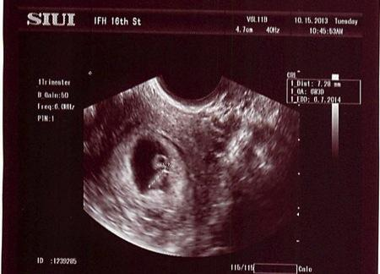

What is your assessment? What is your plan?

Assessment:

* *Based on the ultrasound findings, we can confirm that she has had an early pregnancy loss*
  + *Review the criteria in Appendix C for ultrasound diagnosis – in this case, the CRL is > 7 mm without fetal heart activity, meeting definitive criteria for early pregnancy loss.*
  + *Review the terminology in Appendix B – this case is a missed early pregnancy loss.*
  + *Note that she is 49 days gestation by CRL, not the expected 11 weeks. Demise likely occurred 4 weeks ago.*

Plan:

* *Have the patient come to clinic to see you today.*
* *She does not need to go to the ER, since she has no signs or symptoms of infection or excessive bleeding.*

You have the radiology suite send the patient to your clinic and you add her onto your schedule. You walk in the room to find Mona and her partner. They appear concerned and want to know what is going on.

What can you tell them about early pregnancy loss in general?

* *Early pregnancy loss is very common, about every one in five pregnancies end in early pregnancy loss.*
* *There is nothing that they did wrong to cause this.*
* *Early pregnancy loss is usually caused by a chromosomal abnormality, though definitive diagnosis and etiology is rarely known.*
* *Most people who experience early pregnancy loss have normal subsequent pregnancies.*
* *Bedrest or pelvic rest does not prevent early pregnancy loss*.

How would you counsel them on next steps?

* *Review the three management options for early pregnancy loss.*
* *Use the handout “*[*Early Pregnancy Loss Treatment Options*](https://www.reproductiveaccess.org/resource/miscarriage-treatment-options/)*” if the decision making process seems to warrant additional guidance.*

Mona would like to get a manual vacuum aspiration (MVA) in your clinic. She does not like the idea of having a nonviable pregnancy inside of her, and does not like the idea of bleeding at home. You discuss contraception with her, and she decides she would like an IUD inserted today at the end of the MVA procedure. You obtain consents for both of these procedures.

What are the contraindications, risks, and benefits to office-based MVA?

* *MVA can be done using local anesthesia (a paracervical block) in an office setting up until 10 weeks gestational age. When treating an early pregnancy loss, the gestational dating is based on the ultrasound, not the dates by LMP. In this case, for example, we consider her to have a 7-week rather than 11-week gestation.*
* *Contraindications to office-based MVA: active PID, hemodynamic instability, bleeding disorders. Patients with these can be referred to other centers for safe aspiration procedures, including medical centers or Planned Parenthood. Relative contraindications or patients who require a higher level of expertise (ie. Bicornuate uterus) can also be referred.*
* *Risks of office-based MVA: pain, bleeding, perforation, and infection – all extremely low.*
* *Benefits of MVA, compared to in-hospital D&C: reduced waiting time, lower cost, low anesthesia requirement, and accessibility to services.*
* *Benefits of MVA, compared to medical or expectant management: higher success rate, more definitive outcome for patients, less bleeding and cramping at home.*
* *Discuss the steps of doing an MVA*
* *See attached photo for supplies needed for an MVA.*
* *Sample consents for MVA and IUD insertions, as well as procedural information can be found via the Reproductive Health Access Project at www.reproductiveaccess.org. Video and additional information can be found on Procedures Consult online, at www.proceduresconsult.com*

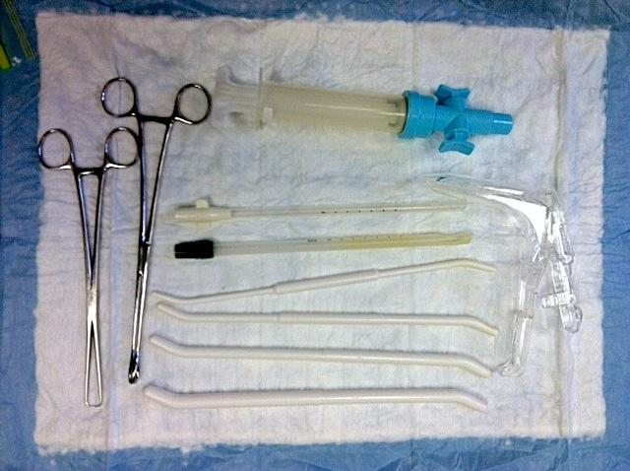

You perform an MVA with local anesthesia and insert the IUD. Mona tolerates the procedure very well, with her partner offering support. On gross tissue exam, you see a typical 7-week gestational sac, which does not need to be sent to pathology because this is her first early pregnancy loss.



* To the bottom right of the photo is a typical 7-week gestational sac with villi, as seen using the "float" technique – placing the MVA contents into a clear container with a small amount of water, and using a backlight. One is able to differentiate the sac and villi from the surrounding decidua (on the left side of the photo) based on the increased vascularity and thickness of the decidual membrane. The villi and sac are less vascular and thinner. In an early pregnancy loss, the villi will be more blunted and may appear more vascular and/or hydropic due to tissue degeneration.
* The sac and villi size will vary based on gestational age, starting at a size less than a dime (~5 weeks) and increasing with gestational age. The sac and villi above are approximately the size of a quarter when suspended in water.
* It is useful in the management of early pregnancy loss to learn to identify products of conception even in clinics that do not perform MVA. Finding POC on tissue brought by the patient, or found on exam, is a useful diagnostic tool.

What else should you do today?

*If these tests were not already done with her prenatal care, you should do:*

* *Rh blood typing and hemoglobin*
* *Healthcare maintenance based on her age: chlamydia and gonorrhea testing, plus risk assessment and testing for other STDs, if indicated*

Learning points for case 3:

* Manual vacuum aspiration (MVA) is a safe office-based option for management or early pregnancy loss.
* MVA can usually be done in the office up to 10 weeks by gestational age (by ultrasound), even if the gestational age by LMP is higher.
* There are few contraindications to MVA for early pregnancy loss management, but include: active PID, hemodynamic instability, and bleeding disorders. These patients can be referred to other centers for safe aspiration procedures, including medical centers or Planned Parenthood.
* Review the common nature of early pregnancy loss, and the importance of reassuring patients that they did nothing to cause this.

END OF CASE

**Case #4: “Sonia” (she/her) Abortion Aftercare or Self-Managed Abortion (SMA)**

You’ve been providing comprehensive EPL care in your primary care office for a few years. Your state passes a severely restrictive law that bans abortions after 9 weeks gestation. This does not affect your provision of EPL care, but you know it affects your patients because you often provide pregnancy options counseling and referrals to abortion care.

You get a call from one of your long term patients. She tells you that her 32-year-old female friend, Sonia, is with her and needs medical care and doesn’t know where to else go. Sonia doesn’t typically have a primary care office where she goes for routine health care. She realized she was pregnant when she was already at 10 weeks’ gestation and knew she wouldn’t be able to get an abortion in her state. As a result, the nearest abortion clinic would have been over 100 miles away and she would have had to wait an extra day between counseling and the abortion due to the state’s 24-hour mandatory waiting period. Sonia didn’t have the ability to take off work so long, so she obtained misoprostol pills and decided to self-manage her abortion on her own terms.

Sonia found instructions on [how to use abortion pills with misoprostol](https://www.reproductiveaccess.org/resource/mabfactsheet-miso/) from the Reproductive Health Access Project and followed them.

You ask for Sonia to come to the phone. She explains that she took the misoprostol pills vaginally according to the instructions.

What else do you want to know?

* *LMP? G’s and P’s*
* *How much has she been bleeding, how many pads per day or per hour?*
* *Is she feeling light-headed or dizzy?*
* *Any fever?*
* *Did she see any tissue pass?*
* *Did she ever get an ultrasound to establish that her pregnancy was intrauterine?*

Sonia tells you that her last period was about 11 weeks before she took the pills; she is G4P3. After she took the medicines (4 pills every 3 hours x 3 times), she had heavy bleeding with clots for 4 hours and saw some gray/yellow tissue in the toilet. The bleeding after that was about four pads a day for a few days. For the past 3 weeks, she has had intermittent light bleeding. She’s worried.

What advice would you give Sonia ?

* *This could be a normal post-abortion course.*
* *Refer to Appendix D and E*
* *If Sonia is worried, she could see you in your office.*

She’s really worried, so you offer to see her in the office. Before Sonia agrees, she asks whether something bad can happen because she self-sourced her abortion.

How do you respond?

* *Because abortion care and EPL care look so similar, you can and should take care of Sonia like any patient who had a pregnancy loss: checking up on symptoms and assessing for completeness.*
* *You do not and will not share any information about Sonia to the authorities because there is no reason to and no mandatory reporting around self-managed abortion. As clinicians, our responsibility is to take care of our patients’ health and well-being.*

She comes to the office. What do you need to do?

* *Vitals, fingerstick, hemoglobin, urine bhCG.*

Her blood pressure is 110/60, her heart rate is 90, she does not appear pale, clammy, or cold. Her urine pregnancy test is negative. Her fingerstick Hgb is 9.0. She reports that the bleeding has slowed down again. Physical exam reveals no blood in the vagina, and a normal-sized, nontender uterus.

What do you think now and what are your next steps?

* *Today’s exam confirms that she is no longer pregnant.*
* *She is mildly anemic, but hemodynamically stable.*
* *This is a typical medication abortion course, with several weeks of stop-and-start bleeding.*
* *She needs oral iron supplementation*
* *Ask if she’s interested in talking about any contraception options.*

What if she hadn’t been willing or able to come to the office? Would you have been able to handle this by phone?

* *You can assess the severity of bleeding and symptoms of anemia/hemodynamic instability (dizziness, fatigue, shortness of breath, etc.) by phone. If the patient is asymptomatic, you can advise them to take a home pregnancy test. A negative result makes the office visit unnecessary.*
* *This history is not unusual for a medication abortion, some people do bleed up until their next period. It is also important to know that the first period after a medication abortion is often quite heavy and patients may call when this happens if they have not been prepared for it.*

What barriers to abortion care do people living in severely restricted states face? What might more underserved, marginalized communities – like immigrants, people of color, people living in rural areas, and folks working to make ends meet – face in particular?

* *Cost of taking extended time off work, finding childcare, finding transportation/lodging, long distances to travel*
* *High cost of abortion care, especially as delays may push first trimester abortion to second trimester & lack of Medicaid coverage*
* *More marginalized, underserved communities have less access to social supports and resources to navigate the restrictions and rules and find abortion care in a timely way*
* *Stigma, fear, confusion in terms of whether abortion care is legal, and the rules to navigate*
* *Studies exploring why people self-manage / self-source their abortions find that people choose SMA because of the inaccessibility of in-clinic based care in states with highly restrictive abortion laws AND because of preference. Some people prefer to self-manage their abortion because of the privacy and autonomy this option offers, which may also highlight the experiences of racism and stigma people experience in the medical setting.*
* *These communities are most impacted by the surveillance of pregnant people. Medicaid beneficiaries are more likely to come to the attention of law enforcement for pregnancy-related issues and people of color are more likely to face arrest for their pregnancy outcomes.*

Sonia didn’t tell us where she got the misoprostol pills, but she knows they were misoprostol.

* *Studies have shown that when someone buys abortion pills online or in pharmacies (misoprostol) in Mexico and other places, these medicines do, in fact, contain the ingredients in the appropriate percentages.*
* *Misoprostol may be easier to obtain than mifepristone, but both protocols for abortion with medications are safe and effective. Complications and incomplete abortion are infrequent. But if they do occur, we need to support patients comprehensively and with dignity.*
* *Just like Sonia, some people self-managing seek out clinician support because they want some reassurance to make sure the abortion process is happening as it should.*
* *Several hotlines and resources exist to support people in the U.S. who are looking to self-manage their abortion:*
  + M+A Hotline: https://www.mahotline.org/
  + Plan C: <https://www.plancpills.org/>
  + Reprocare: <https://reprocare.com/>
  + AidAccess: <https://aidaccess.org/en/>

END OF CASE

**References**

1. ACOG Practice Bulletin No. 101: ultra- sonography in pregnancy. Obstet Gynecol 2009;113:451-61
2. Aiken A, Starling J, Gomperts R. Factors associated with use of an online telemedicine service to access self-managed medical abortion in the US. JAMA Netw Open. 2021;4(5):e2111852.
3. Barnhart, KT. Early pregnancy failure: beware of the pitfalls of modern management. Fertility and sterility 2012; 98(5): 1061-1065.
4. Barnhart KT, et al. Symptomatic patients with an early viable intrauterine pregnancy: HCG curves redefined. Obstet Gynecol. 2004;104(1):50-55
5. Barnhart KT, van Mello NM, et al. Pregnancy of unknown location: a consensus statement of nomenclature, definitions, and outcome. Fertil Steril 2011; 95:857-66.
6. Bree RL, Edwards M, et al. Trans-vaginal sonography in the evaluation of normal early pregnancy: correlation with hCG level. AJR Am J Roentgenol 1989;153: 75-9.
7. Chen BA, Creinin MD.  Contemporary management of early pregnancy failure.  Clin Obstet Gynecol.  2007;50(1):67–88.
8. Casikar I, Bignardi T, et al. Expectant management of spontaneous first-trimester miscarriage: prospective validation of the ‘2-week rule’. Ultrasound Obstet Gynecol 2010;35(2):223-7.
9. Crochet JR., Bastian LA, Chireau MV. Does This Woman Have an Ectopic Pregnancy? The Rational Clinical Examination Systematic Review Diagnosing an Ectopic Pregnancy. JAMA 2013; 309(16): 1722-1729.
10. Doubilet PM, et al. Diagnostic Criteria for Nonviable Pregnancy Early in the First Trimester. N Engl J Med 2013;369(15): 1443-51.
11. Doubilet PM, Benson CB. Further evidence against the reliability of the human chorionic gonadotropin discriminatory level. J Ultrasound Med 2011;30:1637-42.
12. Deutchman M, Tubay AT, Turok DK. First trimester bleeding. Am Fam Physician 2009;79:985-94.
13. If/When/How. Supporting people who end pregnancies: necessary for reproductive justice. Available at: https://www.ifwhenhow.org/wp-content/uploads/2020/04/FINAL-Fact-Sheet-Self-Managed-Abortion-.pdf. Accessed February 11, 2021.
14. [Jeve Y](http://www.ncbi.nlm.nih.gov/pubmed?term=Jeve%20Y%5BAuthor%5D&cauthor=true&cauthor_uid=21997875), [Rana R](http://www.ncbi.nlm.nih.gov/pubmed?term=Rana%20R%5BAuthor%5D&cauthor=true&cauthor_uid=21997875), [Bhide A](http://www.ncbi.nlm.nih.gov/pubmed?term=Bhide%20A%5BAuthor%5D&cauthor=true&cauthor_uid=21997875), [Thangaratina S](http://www.ncbi.nlm.nih.gov/pubmed?term=Thangaratinam%20S%5BAuthor%5D&cauthor=true&cauthor_uid=21997875). Accuracy of first-trimester ultrasound in the diagnosis of early embryonic demise: a systematic review. Ultrasound Obstet Gynecol. 2011;38(5):489-96.
15. Love E, Bhattachararya S, et al. Effect of interpregnancy interval on outcome of pregnancy after miscarriage: retrospective analysis of hospital episode statistics in Scotland. BMJ 2010; 341:c3967.
16. Luise C, Jermy K, et al. Outcome of expectant management of spontaneous first trimester miscarriage: observational study. BMJ 2002; 324(7342): 873-5.
17. Murtagh C, Wells E, Raymond EG, Coeytaux F, Winikoff B. Exploring the feasibility of obtaining mifepristone and misoprostol from the internet. Contraception. 2018;97(4):287-291. doi: 10.1016/j.contraception.2017.09.016.
18. Nanda K, Lopez LM, Grimes DA, Peloggia A, Nanda G. Expectant care versus surgical treatment for miscarriage. Cochrane Database Syst Rev. 2012;14(3).
19. Neilson JP, Gyte GM, et al. Medical treatments for incomplete miscarriage. Cochrane Database Syst Rev. 2013; 28(3).
20. Poulose  T, Richardson  R, Ewings  P, Fox  R.  Probability of early pregnancy loss in women with vaginal bleeding and a singleton live fetus at ultrasound scan.  J Obstet Gynaecol.  2006;26(8):782–784.
21. Prine LW, MacNaughton H. [Office management of early pregnancy loss.](http://www.ncbi.nlm.nih.gov/pubmed/21766758) Am Fam Physician. 2011;84(1):75-82.
22. Ralph L, Foster DG, Raifman S. Prevalence of self-managed abortion among women of reproductive age in the United States. JAMA Netw Open. 2020;3(12):e2029245.
23. Silva C, et al. "Human chorionic gonadotropin profile for women with ectopic pregnancy." Obstetrics & Gynecology 2006;107(3): 605-610.
24. Sotriadis A, Makydimas G, Papatheodorou S, Ioannidis JP. Expectant, medical, or surgical management of first-trimester miscarriage: a meta-analysis. Obstet Gynecol. 2005; 105(5.1):1104-13.
25. van Mello NM, et al. Ectopic pregnancy: how the diagnostic and therapeutic management has changed. Fertility and sterility 2012;98(5): 1066-1073.
26. Schreiber, CA et al. Mifepristone Pretreatment for the Medical Management of Early Pregnancy Loss N Engl J Med 2018; 378:2161-2170
27. Weaver G, Schiavon R, Collado ME*, et al*. Misoprostol knowledge and distribution in Mexico City after the change in abortion law: a survey of pharmacy staff. BMJ Sexual & Reproductive Health.2020; 46:46-50. doi: [10.1136/bmjsrh-2019-200394](http://dx.doi.org/10.1136/bmjsrh-2019-200394)

**Appendix A: First Trimester Bleeding algorithm**



Source: <https://www.reproductiveaccess.org/resource/first-trimester-bleeding-algorithm/>



Source:

**Appendix B: Classification of early pregnancy loss**

|  |  |  |  |
| --- | --- | --- | --- |
| Classification | Vaginal bleeding | Endometrial thickness | Products of conception seen on ultrasound |
| Complete early pregnancy loss | Little or none | Any, though typically < 15 mm | None |
| Incomplete early pregnancy loss | Little or none | Any | Heterogeneous tissues (with or without a gestational sac) distorting the endometrial midline |
| Embryonic or fetal demise | Yes or no | Any | Gestational sac with fetal tissue (i.e. fetal pole or yolk sac) present, meeting ultrasound criteria for SAB (i.e. > 7 mm with no FH) |
| Anembryonic pregnancy | Yes or no | Any | Gestational sac without fetal tissue (ie. no fetal pole or yolk sac) present, meeting ultrasound criteria for SAB (i.e. MSD > 25 mm without yolk sac) |

**Appendix C: Ultrasonographic criteria for early pregnancy loss**

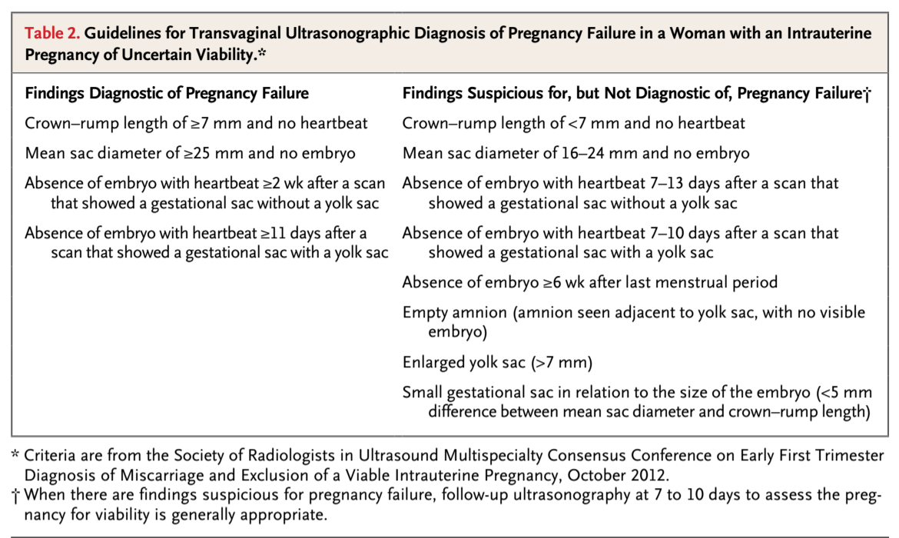

Source: Doubilet P, et al. Diagnostic Criteria for Nonviable Pregnancy Early in the First Trimester. N Engl J Med 2013;369(15): 1443-51.

Appendix D: How to Use Abortion Pills

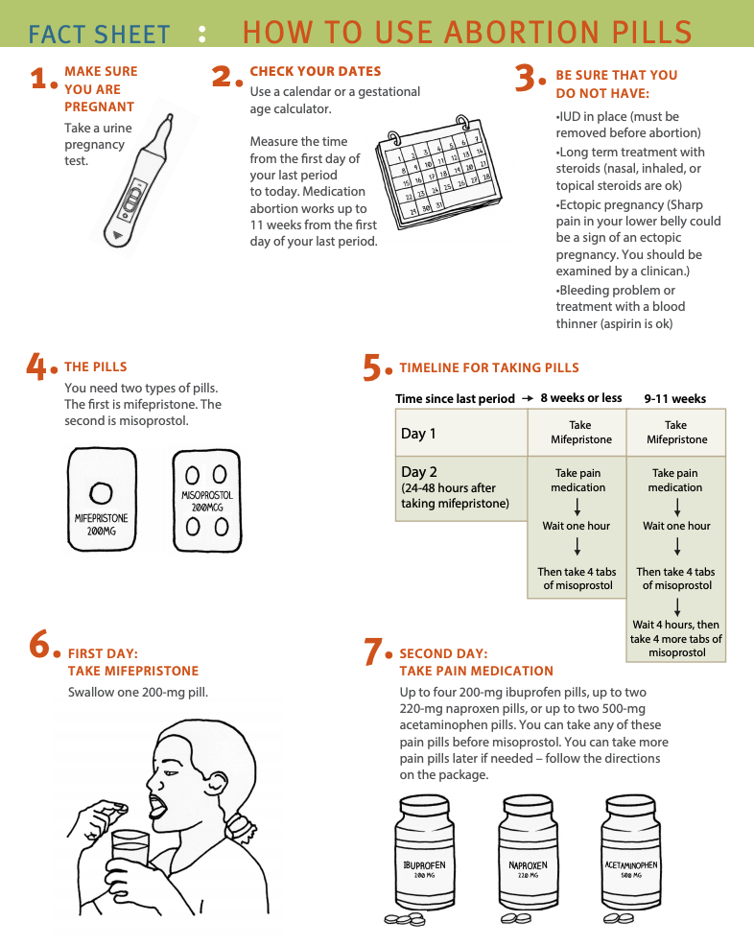

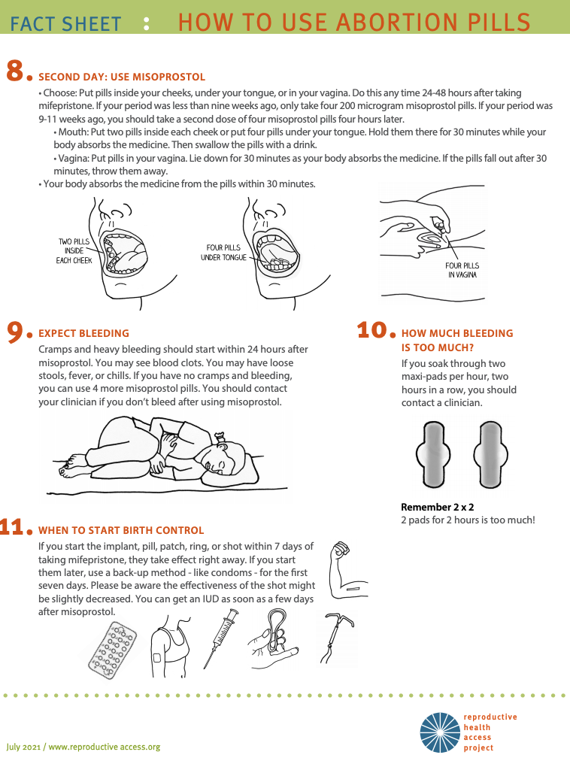

Source: https://www.reproductiveaccess.org/resource/mabfactsheet/

Appendix E: How to Use Abortion Pills (Misoprostol Only)

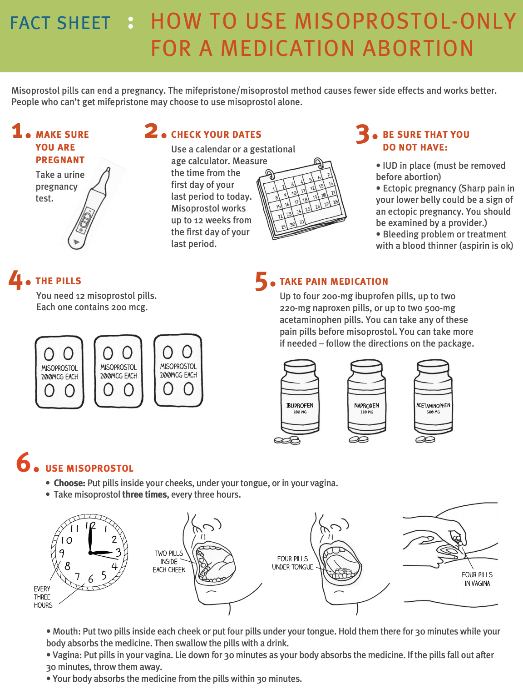

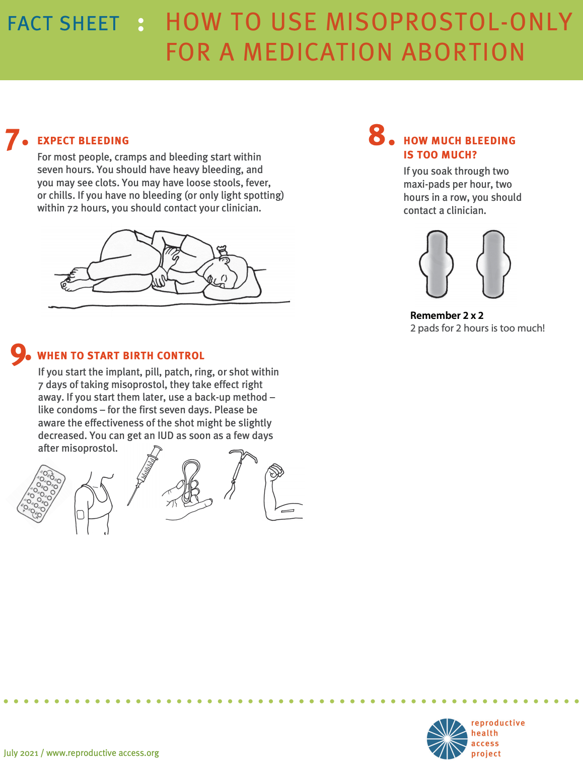

Source: https://www.reproductiveaccess.org/resource/mabfactsheet-miso/