**Early Pregnancy Loss Management Workshop**

**Case Studies Learner’s Guide**

The following set of cases is designed to teach some of the key components of early pregnancy loss evaluation and management. Your facilitator will help you work through the cases. Attached to this guide are several resources including: (Appendix A) an algorithm for the evaluation of first trimester bleeding, (Appendix B) a definition table for types of first trimester loss, (Appendix C) a table of diagnostic criteria needed to diagnose early pregnancy loss by ultrasound, and (Appendix D) factsheets on self-managed abortion. Please feel free to reference the appendix throughout the cases.

**Case # 1: “Melissa” (she/her)**

You are the on-call clinician at night for your practice. You receive a call at 6 am from Melissa, who reports she is early in pregnancy, and has had 3 days of vaginal spotting. She is now calling because she is having more bleeding and clots for the last 2 hours. She is wondering if she needs to go to the emergency room. What additional information do you need?

Melissatells you she is a 34-year-old woman G4P3003 with no significant medical problems, and her only medication is a prenatal vitamin. Her pregnancy test was first positive 2 weeks ago, after she missed her period. She tells you her LMP was 8 weeks ago. She was seen last week in the office and was scheduled for an ultrasound, but has not had it done yet.

For the last 3 days, she describes a small amount of red blood when wiping each day but without cramping. For the last 2 hours, she has had bleeding heavier than a period, with 2-3 clots the size of golf balls. She has soaked 3 maxi pads in the last 2 hours. She has no history of bleeding problems or anemia, and has no lightheadedness or dizziness. She has mild cramps like menses, but no other pelvic pain. She feels overall well, just worried. What should you tell her?

Melissacomes to the office that morning to meet you. She tells you she had about 2 more hours of heavy bleeding but it then slowed down. She is now changing her pad every 4 hours and the cramping has improved. You assess her feelings about the pregnancy and learn that she was trying to get pregnant with her 4th child. Her urine pregnancy test is positive (don’t forget to check this since a negative pregnancy test confirms completed pregnancy loss and saves a lot of worry).

You do an exam which shows:

BP: 108/56, P: 74, R: 16, T= 98.6 Pox: 100%

Speculum: multiparous slightly open cervix, moderate amount of brown and red blood in vaginal vault. No products of conception or large clots are seen.

Bimanual exam: uterus 5-6 weeks size, no uterine or adnexal masses or tenderness

What can we tell Melissaabout what’s going on?

What should we do next?

You do a transvaginal ultrasound. Describe the results.

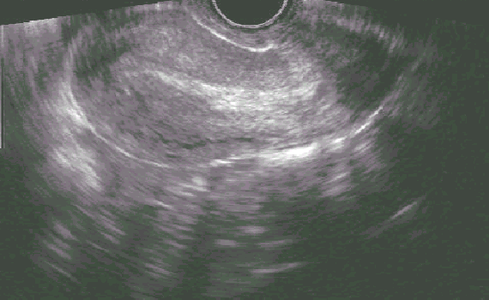

What is your differential diagnosis? What will you tell Melissaabout what is going on? Does not seeing any adnexal masses definitively rule out ectopic?

What is your plan? Are there any other labs you might want to get?

Melissa’sinitial beta-HCG level comes back at 8,150 and 48 hours later it is 1,094. Her hemoglobin is 11.4. What is your diagnosis now?

Do we need to follow the quants to zero? How long might they take to get there?

Melissaasks when she can start trying to get pregnant again. What should you say?

If Melissadidn’t want to get pregnant again, when could you insert an IUD, if that was her preference?

END OF CASE

Write down some of the key learning points:

**Case # 2: “Dee” (they/them)**

Dee is here for their first prenatal appointment with their partner, Max. They are a 29-year-old G2P1001 with a history of gallstones but is otherwise healthy. They had an uncomplicated vaginal delivery 3 years ago. Dee tells you they are sure their LMP was 10 weeks ago, but notes that they had been taking birth control on and off for the last few months. They are excited about the pregnancy, as Dee and their partner had been thinking about trying. They had a positive pregnancy test at home and some nausea a few weeks ago which has since resolved. They have not had bleeding, abdominal pain or cramping.

What should you do next?

You do an exam, which shows:

BP 114/62, HR 80, RR 12, SO2 99%

They appear comfortable and their abdomen is soft and nontender. There is no palpable fundus on abdominal exam.

Dopplers: No fetal heart rate is heard

Bimanual exam: uterus 6-week size, nontender. Adnexa are without mass and nontender.

What is your assessment? What is your plan?

You do a transvaginal ultrasound.

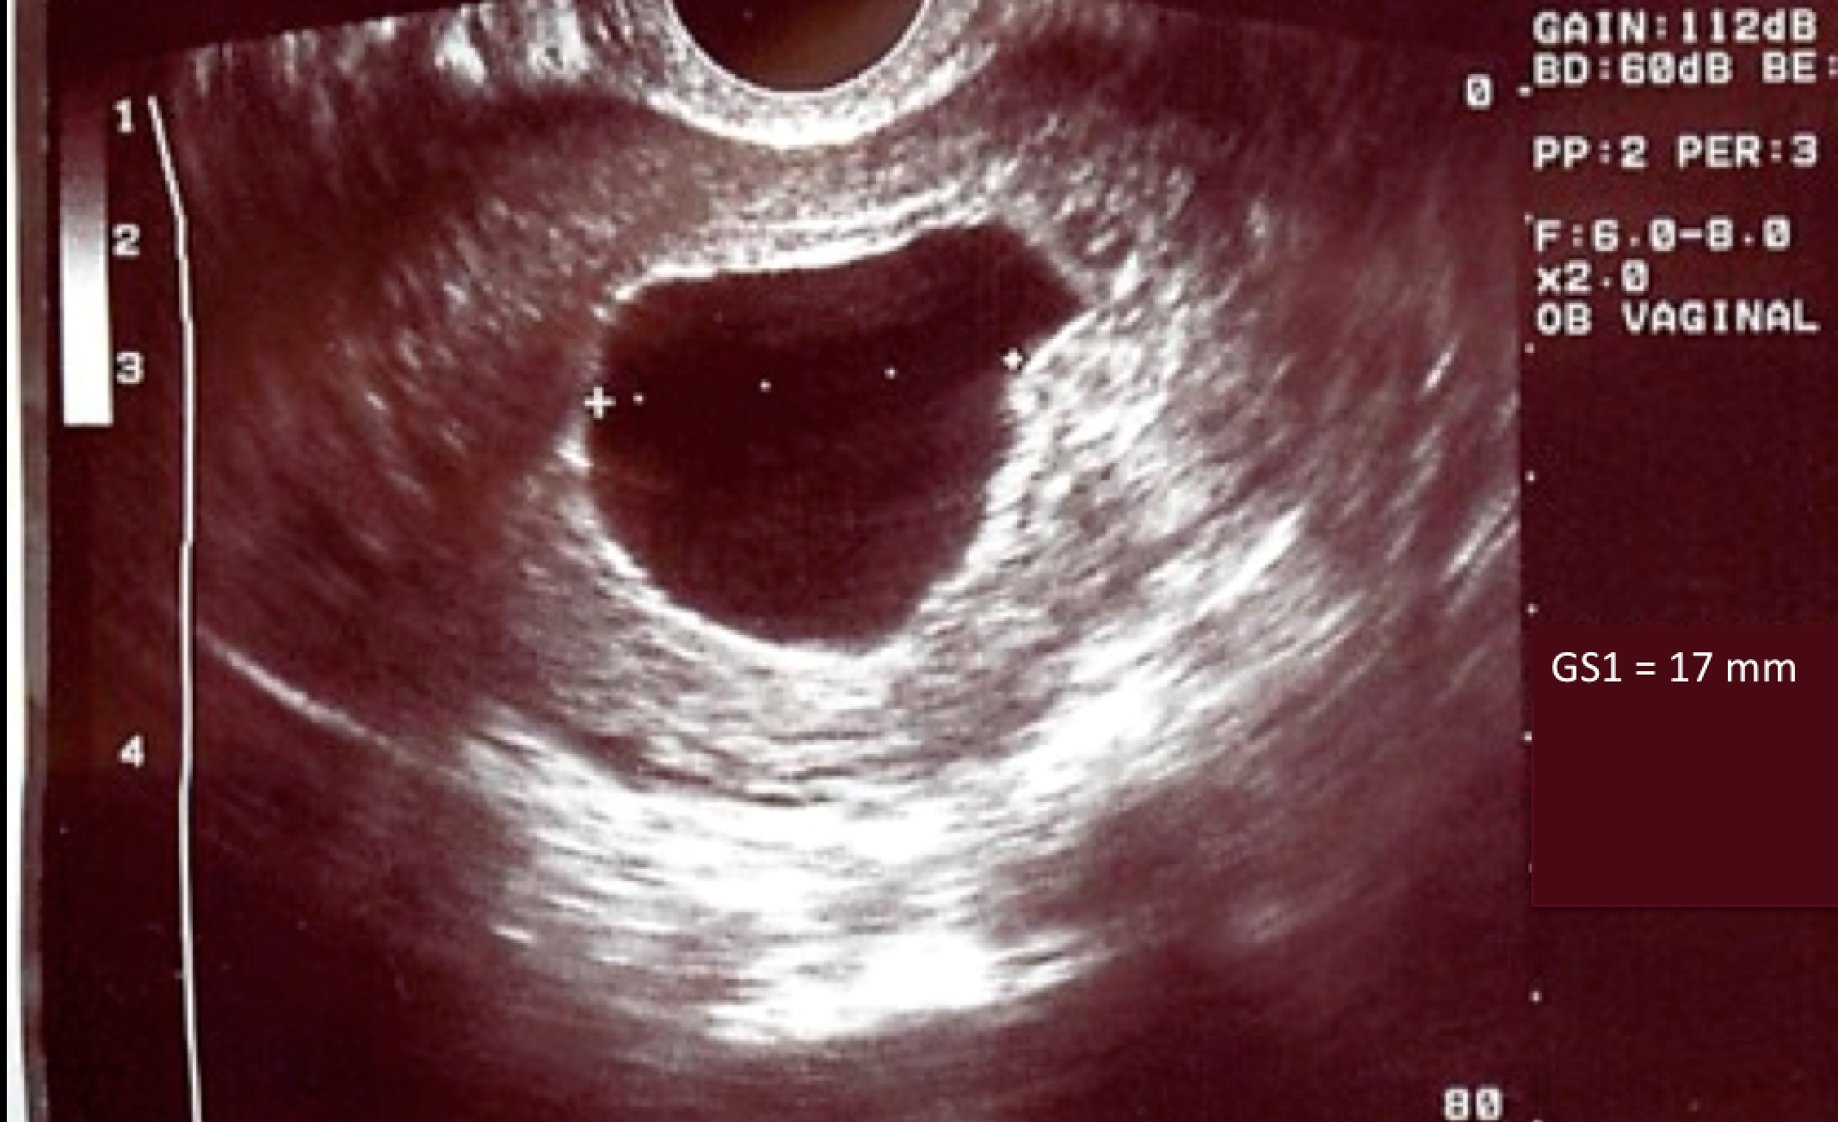

Describe the ultrasound. How do you interpret this ultrasound result?

What should we do next? How should we counsel Dee and Max?

Dee follows up with you 3 days later. Their initial beta-HCG level was 12,480 and their repeat at 48 hours was 10,560. They have had no new symptoms and overall feel well.

What is your diagnosis? What is your plan?

Dee opts to repeat the ultrasound in 14 days to be 100% sure. The ultrasound shows the same large sac and still no fetal pole or yolk sac. What is your diagnosis? What is your plan?

Dee decides to pursue expectant management. They want to avoid any extra medications or procedures, if possible. You counsel them on what to expect and provide them with prescriptions for ibuprofen and hydrocodone-acetaminophen 5/300 #4 tabs to help with cramping pain if needed. Dee has a reliable way of contacting you or your colleagues in case they have questions or concerns.

How often does expectant management work?

What anticipatory guidance do you give Dee regarding when to call?

Two weeks later, they ask to come for a follow up appointment to discuss their options. Dee has not had any heavy bleeding, and only a couple days of light spotting. They are tired of waiting and now want “all this to be over.”

What options would you now offer her?

Dee decides to take the mifepristone and misoprostol. How do you counsel them to use the medications?

Dee takes the mifepristone in the office. Twenty-four hours later, at home, they take 600 mg of ibuprofen, and inserts 800 mcg (four 200 mcg tablets) of misoprostol into the vagina. About one hour later they call you because they have a fever to 100.6 and shaking chills and is worried they have an infection.

Why is Dee having these symptoms?

Dee calls you the next day to let you know that they had about 4 hours of heavy bleeding and clots. Their bleeding has now slowed and it is more like a period. Their fever and chills resolved. Dee returns in one week as planned and you do an ultrasound which no longer shows a gestational sac. You discuss their plans for pregnancy, tell them to continue their prenatal vitamins, and invite them back for prenatal care. You also remind them that grief after an early pregnancy loss can be normal. Anticipatory guidance about grief can be helpful, and a referral to counseling can be considered.

END OF CASE

Write down some of the key learning points:

**Case # 3: “Mona” (she/her)**

You are in the middle of your morning in clinic, when the hospital ultrasonographer calls your office. She is seeing your patient for a nuchal translucency measurement. Your patient, Mona, is a 19-year-old G1 who you are seeing for routine prenatal care following the diagnosis of her pregnancy, which she has decided to continue. Today she should be at 11 weeks and 4 days gestation based on a 6-week ultrasound, which was consistent with LMP. She had been sent to get a routine screening ultrasound, and there were no concerns.

The ultrasonographer notes that there is an intrauterine pregnancy, however the crown-rump length (CRL) is 7.2 mm and has no detectable heartbeat. The patient reported no bleeding or cramping, but did notice that her breasts were less tender and her nausea had improved. The ultrasonographer wants to know if she should send the patient to the ER. The ultrasound is shown:

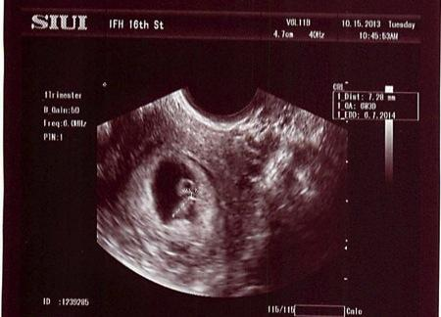

What is your assessment? What is your plan?

You have the radiology suite send the patient to your clinic and you add her onto your schedule. You walk in the room to find Mona and her partner. They appear concerned and want to know what is going on.

What can you tell them about early pregnancy loss in general?

How would you counsel them on next steps?

Mona would like to get a manual vacuum aspiration (MVA) in your clinic. She does not like the idea of having a nonviable pregnancy inside of her, and does not like the idea of bleeding at home. You discuss contraception with her, and she decides she would like an IUD inserted today at the end of the MVA procedure. You obtain consents for both of these procedures.

What are the contraindications, risks, and benefits to office-based MVA?

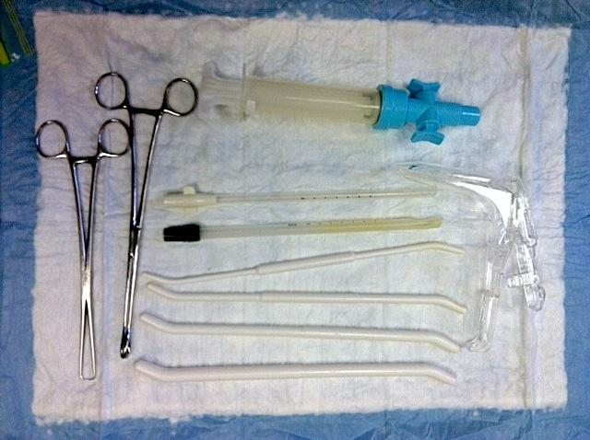

You perform an MVA with local anesthesia and insert the IUD. Mona tolerates the procedure very well, with her partner offering support. On gross tissue exam, you see a typical 7-week gestational sac, which does not need to be sent to pathology because this is her first early pregnancy loss.



* To the bottom right of the photo is a typical 7-week gestational sac with villi, as seen using the "float" technique – placing the MVA contents into a clear container with a small amount of water, and using a backlight. One is able to differentiate the sac and villi from the surrounding decidua (on the left side of the photo) based on the increased vascularity and thickness of the decidual membrane. The villi and sac are less vascular and thinner. In an early pregnancy loss, the villi will be more blunted and may appear more vascular and/or hydropic due to tissue degeneration.
* The sac and villi size will vary based on gestational age, starting at a size less than a dime (~5 weeks) and increasing with gestational age. The sac and villi above are approximately the size of a quarter when suspended in water.
* It is useful in the management of early pregnancy loss to learn to identify products of conception even in clinics that do not perform MVA. Finding POC on tissue brought by the patient, or found on exam, is a useful diagnostic tool.

What else should you do today?

END OF CASE

Write down some of the key learning points:

**Case #4: “Sonia” (she/her) Abortion Aftercare or Self-Managed Abortion (SMA)**

You’ve been providing comprehensive EPL care in your primary care office for a few years. Your state passes a severely restrictive law that bans abortions after 9 weeks gestation. This does not affect your provision of EPL care, but you know it affects your patients because you often provide pregnancy options counseling and referrals to abortion care.

You get a call from one of your long term patients. She tells you that her 32-year-old female friend, Sonia, is with her and needs medical care and doesn’t know where to else go. Sonia doesn’t typically have a primary care office where she goes for routine health care. She realized she was pregnant when she was already at 10 weeks’ gestation and knew she wouldn’t be able to get an abortion in her state. As a result, the nearest abortion clinic would have been over 100 miles away and she would have had to wait an extra day between counseling and the abortion due to the state’s 24-hour mandatory waiting period. Sonia didn’t have the ability to take off work so long, so she obtained misoprostol pills and decided to self-manage her abortion on her own terms.

Sonia found instructions on [how to use abortion pills with misoprostol](https://www.reproductiveaccess.org/resource/mabfactsheet-miso/) from the Reproductive Health Access Project and followed them.

You ask for Sonia to come to the phone. She explains that she took the misoprostol pills vaginally according to the instructions.

What else do you want to know?

Sonia tells you that her last period was about 11 weeks before she took the pills; she is G4P3. After she took the medicines (4 pills every 3 hours x 3 times), she had heavy bleeding with clots for 4 hours and saw some gray/yellow tissue in the toilet. The bleeding after that was about four pads a day for a few days. For the past 3 weeks, she has had intermittent light bleeding. She’s worried.

What advice would you give Sonia ?

She’s really worried, so you offer to see her in the office. Before Sonia agrees, she asks whether something bad can happen because she self-sourced her abortion.

How do you respond?

She comes to the office. What do you need to do?

Her blood pressure is 110/60, her heart rate is 90, she does not appear pale, clammy, or cold. Her urine pregnancy test is negative. Her fingerstick Hgb is 9.0. She reports that the bleeding has slowed down again. Physical exam reveals no blood in the vagina, and a normal-sized, nontender uterus.

What do you think now and what are your next steps?

What if she hadn’t been willing or able to come to the office? Would you have been able to handle this by phone?

What barriers to abortion care do people living in severely restricted states face? What might more underserved, marginalized communities – like immigrants, people of color, people living in rural areas, and folks working to make ends meet – face in particular?

* *Cost of taking extended time off work, finding childcare, finding transportation/lodging, long distances to travel*
* *High cost of abortion care, especially as delays may push first trimester abortion to second trimester & lack of Medicaid coverage*
* *More marginalized, underserved communities have less access to social supports and resources to navigate the restrictions and rules and find abortion care in a timely way*
* *Stigma, fear, confusion in terms of whether abortion care is legal, and the rules to navigate*
* *Studies exploring why people self-manage / self-source their abortions find that people choose SMA because of the inaccessibility of in-clinic based care in states with highly restrictive abortion laws AND because of preference. Some people prefer to self-manage their abortion because of the privacy and autonomy this option offers, which may also highlight the experiences of racism and stigma people experience in the medical setting.*
* *These communities are most impacted by the surveillance of pregnant people. Medicaid beneficiaries are more likely to come to the attention of law enforcement for pregnancy-related issues and people of color are more likely to face arrest for their pregnancy outcomes.*

END OF CASE

Write down some key learning points:

**References**

1. ACOG Practice Bulletin No. 101: ultra- sonography in pregnancy. Obstet Gynecol 2009;113:451-61
2. Aiken A, Starling J, Gomperts R. Factors associated with use of an online telemedicine service to access self-managed medical abortion in the US. JAMA Netw Open. 2021;4(5):e2111852.
3. Barnhart, KT. Early pregnancy failure: beware of the pitfalls of modern management. Fertility and sterility 2012; 98(5): 1061-1065.
4. Barnhart KT, et al. Symptomatic patients with an early viable intrauterine pregnancy: HCG curves redefined. Obstet Gynecol. 2004;104(1):50-55
5. Barnhart KT, van Mello NM, et al. Pregnancy of unknown location: a consensus statement of nomenclature, definitions, and outcome. Fertil Steril 2011; 95:857-66.
6. Bree RL, Edwards M, et al. Trans-vaginal sonography in the evaluation of normal early pregnancy: correlation with hCG level. AJR Am J Roentgenol 1989;153: 75-9.
7. Chen BA, Creinin MD.  Contemporary management of early pregnancy failure.  Clin Obstet Gynecol.  2007;50(1):67–88.
8. Casikar I, Bignardi T, et al. Expectant management of spontaneous first-trimester miscarriage: prospective validation of the ‘2-week rule’. Ultrasound Obstet Gynecol 2010;35(2):223-7.
9. Crochet JR., Bastian LA, Chireau MV. Does This Woman Have an Ectopic Pregnancy? The Rational Clinical Examination Systematic Review Diagnosing an Ectopic Pregnancy. JAMA 2013; 309(16): 1722-1729.
10. Doubilet PM, et al. Diagnostic Criteria for Nonviable Pregnancy Early in the First Trimester. N Engl J Med 2013;369(15): 1443-51.
11. Doubilet PM, Benson CB. Further evidence against the reliability of the human chorionic gonadotropin discriminatory level. J Ultrasound Med 2011;30:1637-42.
12. Deutchman M, Tubay AT, Turok DK. First trimester bleeding. Am Fam Physician 2009;79:985-94.
13. If/When/How. Supporting people who end pregnancies: necessary for reproductive justice. Available at: https://www.ifwhenhow.org/wp-content/uploads/2020/04/FINAL-Fact-Sheet-Self-Managed-Abortion-.pdf. Accessed February 11, 2021.
14. [Jeve Y](http://www.ncbi.nlm.nih.gov/pubmed?term=Jeve%20Y%5BAuthor%5D&cauthor=true&cauthor_uid=21997875), [Rana R](http://www.ncbi.nlm.nih.gov/pubmed?term=Rana%20R%5BAuthor%5D&cauthor=true&cauthor_uid=21997875), [Bhide A](http://www.ncbi.nlm.nih.gov/pubmed?term=Bhide%20A%5BAuthor%5D&cauthor=true&cauthor_uid=21997875), [Thangaratina S](http://www.ncbi.nlm.nih.gov/pubmed?term=Thangaratinam%20S%5BAuthor%5D&cauthor=true&cauthor_uid=21997875). Accuracy of first-trimester ultrasound in the diagnosis of early embryonic demise: a systematic review. Ultrasound Obstet Gynecol. 2011;38(5):489-96.
15. Love E, Bhattachararya S, et al. Effect of interpregnancy interval on outcome of pregnancy after miscarriage: retrospective analysis of hospital episode statistics in Scotland. BMJ 2010; 341:c3967.
16. Luise C, Jermy K, et al. Outcome of expectant management of spontaneous first trimester miscarriage: observational study. BMJ 2002; 324(7342): 873-5.
17. Murtagh C, Wells E, Raymond EG, Coeytaux F, Winikoff B. Exploring the feasibility of obtaining mifepristone and misoprostol from the internet. Contraception. 2018;97(4):287-291. doi: 10.1016/j.contraception.2017.09.016.
18. Nanda K, Lopez LM, Grimes DA, Peloggia A, Nanda G. Expectant care versus surgical treatment for miscarriage. Cochrane Database Syst Rev. 2012;14(3).
19. Neilson JP, Gyte GM, et al. Medical treatments for incomplete miscarriage. Cochrane Database Syst Rev. 2013; 28(3).
20. Poulose  T, Richardson  R, Ewings  P, Fox  R.  Probability of early pregnancy loss in women with vaginal bleeding and a singleton live fetus at ultrasound scan.  J Obstet Gynaecol.  2006;26(8):782–784.
21. Prine LW, MacNaughton H. [Office management of early pregnancy loss.](http://www.ncbi.nlm.nih.gov/pubmed/21766758) Am Fam Physician. 2011;84(1):75-82.
22. Ralph L, Foster DG, Raifman S. Prevalence of self-managed abortion among women of reproductive age in the United States. JAMA Netw Open. 2020;3(12):e2029245.
23. Silva C, et al. "Human chorionic gonadotropin profile for women with ectopic pregnancy." Obstetrics & Gynecology 2006;107(3): 605-610.
24. Sotriadis A, Makydimas G, Papatheodorou S, Ioannidis JP. Expectant, medical, or surgical management of first-trimester miscarriage: a meta-analysis. Obstet Gynecol. 2005; 105(5.1):1104-13.
25. van Mello NM, et al. Ectopic pregnancy: how the diagnostic and therapeutic management has changed. Fertility and sterility 2012;98(5): 1066-1073.
26. Schreiber, CA et al. Mifepristone Pretreatment for the Medical Management of Early Pregnancy Loss N Engl J Med 2018; 378:2161-2170
27. Weaver G, Schiavon R, Collado ME*, et al*. Misoprostol knowledge and distribution in Mexico City after the change in abortion law: a survey of pharmacy staff. BMJ Sexual & Reproductive Health.2020; 46:46-50. doi: [10.1136/bmjsrh-2019-200394](http://dx.doi.org/10.1136/bmjsrh-2019-200394)

**Appendix A: First Trimester Bleeding algorithm**



Source: <https://www.reproductiveaccess.org/resource/first-trimester-bleeding-algorithm/>



**Appendix B: Classification of early pregnancy loss**

|  |  |  |  |
| --- | --- | --- | --- |
| Classification | Vaginal bleeding | Endometrial thickness | Products of conception seen on ultrasound |
| Complete early pregnancy loss | Little or none | Any, though typically < 15 mm | None |
| Incomplete early pregnancy loss | Little or none | Any | Heterogeneous tissues (with or without a gestational sac) distorting the endometrial midline |
| Embryonic or fetal demise | Yes or no | Any | Gestational sac with fetal tissue (i.e. fetal pole or yolk sac) present, meeting ultrasound criteria for SAB (i.e. > 7 mm with no FH) |
| Anembryonic pregnancy | Yes or no | Any | Gestational sac without fetal tissue (ie. no fetal pole or yolk sac) present, meeting ultrasound criteria for SAB (i.e. MSD > 25 mm without yolk sac) |

**Appendix C: Ultrasonographic criteria for early pregnancy loss**

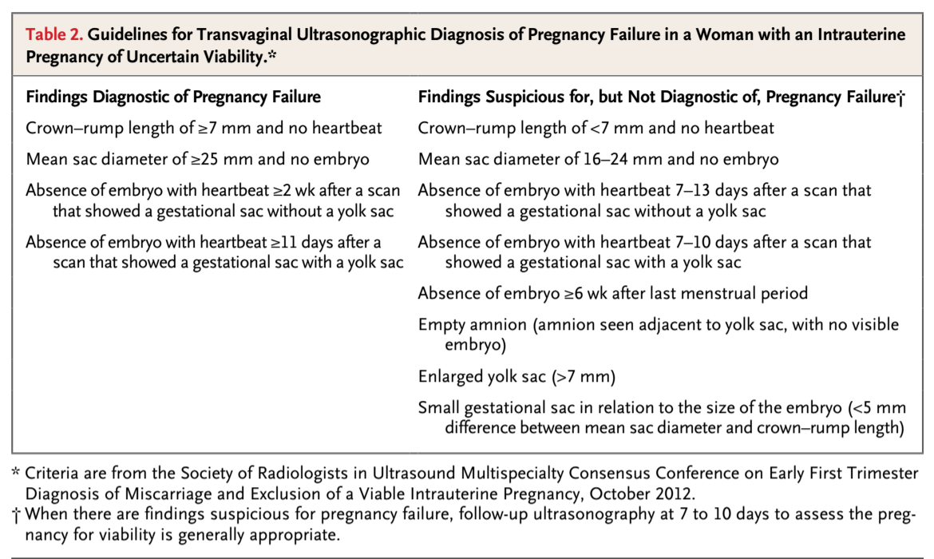

Source: Doubilet P, et al. Diagnostic Criteria for Nonviable Pregnancy Early in the First Trimester. N Engl J Med 2013;369(15): 1443-51.

Appendix D: How to Use Abortion Pills

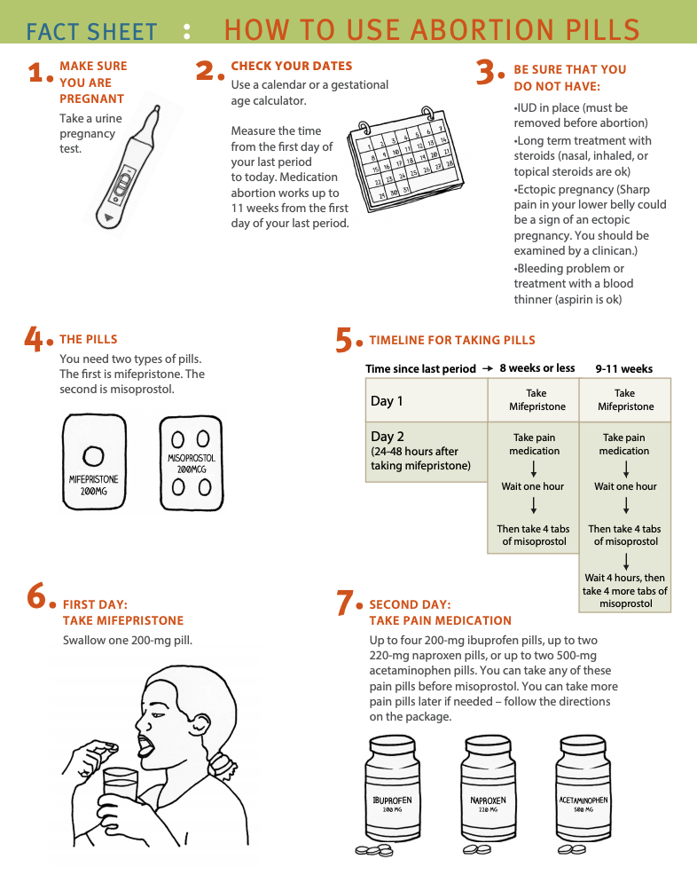

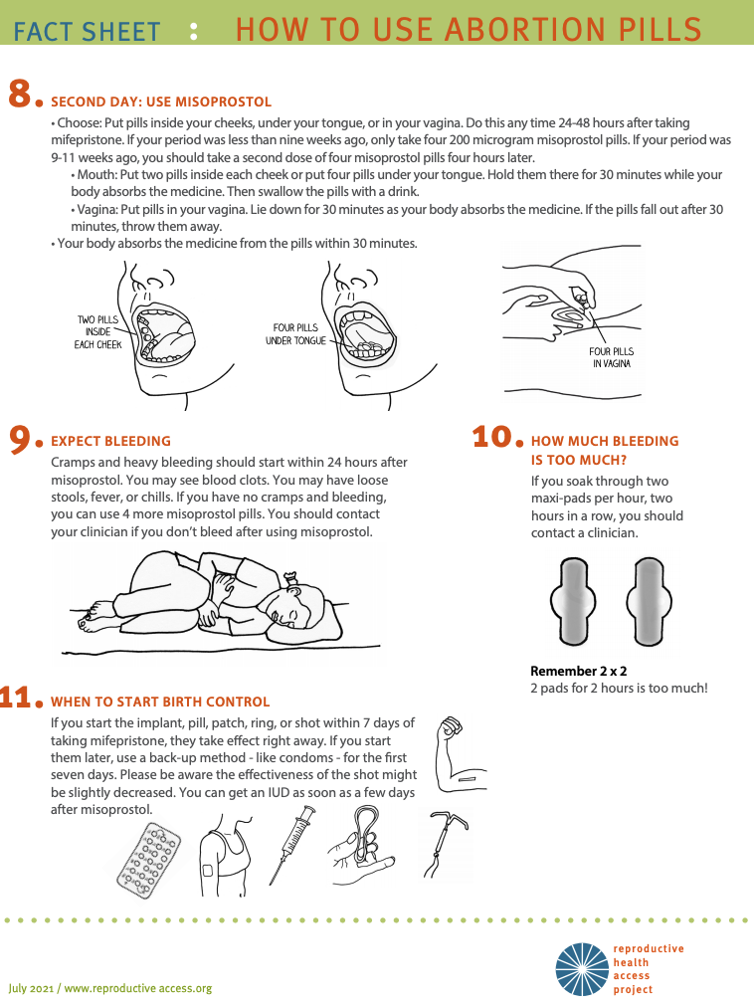

Source: https://www.reproductiveaccess.org/resource/mabfactsheet/

Appendix E: How to Use Abortion Pills (Misoprostol Only)

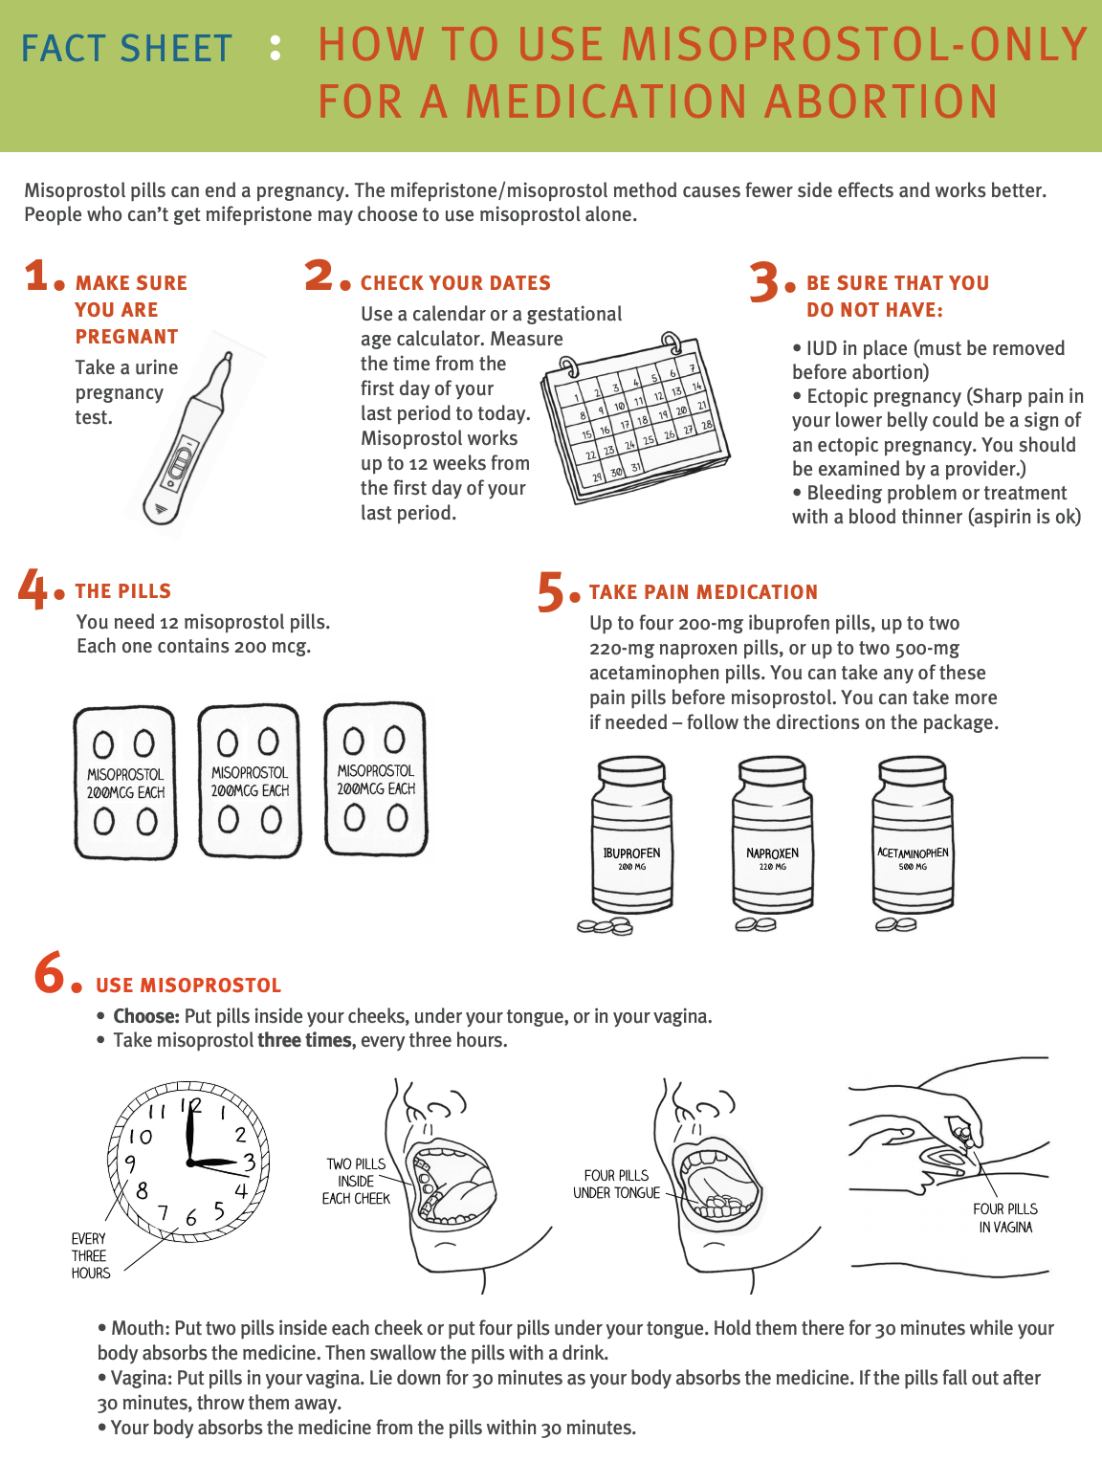

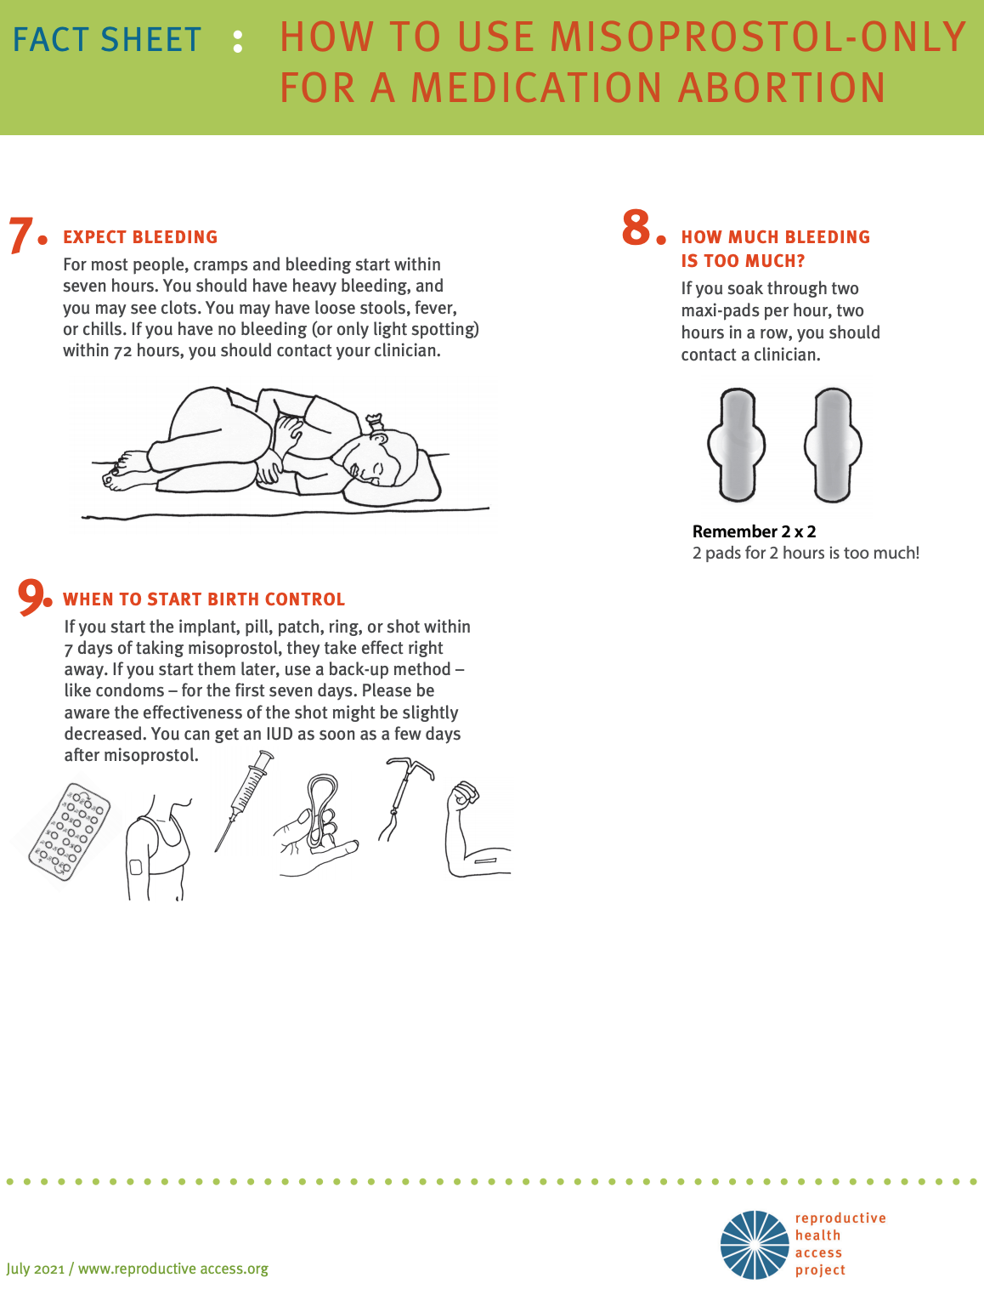

Source: https://www.reproductiveaccess.org/resource/mabfactsheet-miso/