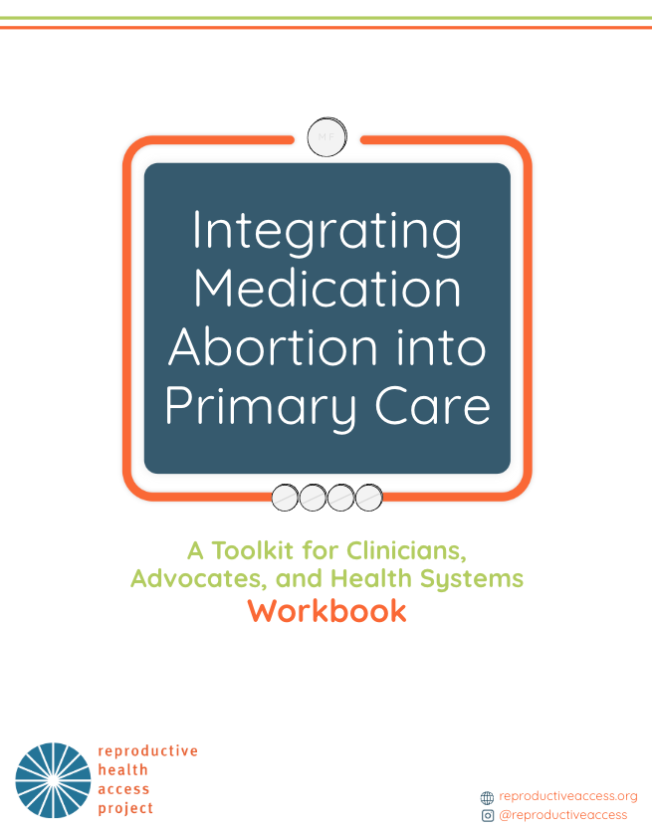
Chapter 1: Establishing a Planning Committee and Building Buy-in
Brainstorm Planning Committee Members and Key Messaging
- Who are clinicians, administrators, and/or other staff at your health center who might want to be involved in implementation of MAB care at your health center?

- Who needs to be involved in the process of implementing a new service at your health center? Are there people who need to give approval for implementing a new service?

- Brainstorm a message to outreach to potential planning committee members. Keep it concise and compelling. Include:
  - Services you want to add and why - highlight the impact of providing MAB to your patients.

  - What stage of planning you are at and who else is involved.

  - The reason you want them involved - why their participation matters.

  - The ask (informal chat, join meeting, etc.).

- Brainstorm a general timeline.
  - I will reach out to all potential committee members by:
  - The first planning committee meeting should be by:
  - Frequency of meetings:

- Do you know anyone who has successfully integrated MAB at their health center, or anyone who has implemented a new service at your health center that would be willing to chat with you about their experience?

Engaging Stakeholders
In addition to assembling a planning committee, you will want to identify and engage relevant stakeholders early on in the planning process. These are people who will not be intimately involved in the implementation of MAB services, but hold power and influence over your potential for success. Consider the key players within and outside your institution and what information or perspective they might need in order to be supportive of implementing MAB into your practice. It is important to understand and address their concerns. Here are some examples:
Role | Name(s) | Supportive? | Priorities/Perspectives
CEO
Board
Compliance
Medical Director
Primary Care Clinicians
OB/GYNs
Nursing Director
Patient Services Director
Operations Director
Hospital/Referral Partner
Primary Care Association
Medicaid Office
Department of Health
Others?

Develop a Pitch
You will want to be able to articulate why and how you are going to do this. This messaging does not have to be delivered all at once, as people are less likely to be open to change if they are overwhelmed with new information. Depending on how open-minded your audience is to providing MAB care at your organization, you may have to be strategic and deliver different messages over time.
- Start with a hook. People most often respond to emotions before they do to data. Did you recently have to refer out a patient you could have cared for? Is abortion access decreasing in your state?

- Articulate your vision. What could MAB care look like at your health center? Let them know you have a plan, but are flexible, and value their feedback/ideas.

- Highlight the value. How does providing MAB benefit the health center and its patients?

- Provide data. Highlight the safety and efficacy of MAB, and the feasibility of providing it in your setting.

- Allow space for questions. Be prepared to address common concerns and myths about MAB.

- Call to action. Clearly state what you are asking for from your audience.

- Follow up. Let your audience know when they will hear from you.

Chapter 2: Administrative and Operational Logistics
Checklist - Prepare to Prescribe Mifepristone
Review the mifepristone payer policies for your state.
Schedule a meeting with your Billing Department to discuss any steps they will need to take in order for you to be able to bill for MAB.
Determine the need and pricing for a self-pay policy.
Once you have a sense of the extent of insurance coverage in your state, research and outreach to local abortion funds to determine if they would be available to partner with you to help cover the cost of providing care to patients who won’t be able to use insurance.
Reach out to the appropriate department to determine how insurance verification checks and presumptive eligibility work at your health center.
Determine if your professional liability insurance covers MAB. You will likely need to review your policy and application for coverage. This may require legal support. If so, reach out to the Abortion Defense Network for assistance.
Determine how prescribing will work and submit the necessary Prescriber Agreement Forms by answering these questions:

- Who will become a certified prescriber?

- Do we have a process in place for ordering and stocking medications that mifepristone can be added to?

- Does dispensing the medication on site work with our workflow?

- Will we be providing telehealth, or only in-person care?

- Are there any certified pharmacies nearby?

- Will my patients feel comfortable picking up the medication at a pharmacy?

- Will my patients have privacy concerns picking up the medication at a pharmacy or receiving it through the mail?

Chapter 3: Preparing Staff
Training Needs Assessment and Planning
Having a structure for training current staff and onboarding new staff will help ensure the consistency and quality of care for all patients. Assess staff training needs in the following areas:
- Scheduling appointments and telephone triage
- Telehealth coordination
- Counseling and consent
- Ultrasound training, if needed
- Emergency preparedness and safety
- Sterilization and disinfection
- Fetal tissue questions and disposal, where applicable

Brainstorming for Training
- What will the clinical flow look like from the time a patient makes an appointment to follow-up?

- How will you incorporate training into your onboarding process?

- How will you determine when staff have been sufficiently trained to perform a new role in the clinic? Who will determine this?

- Will you allow current staff to opt-out of participating in MAB care? Will there be a process in place for opting out?

- Do you have current staff with the necessary skills to train new learners, or will you need to bring in external trainers?

Needs Assessment
What roles will be involved in MAB care? It is helpful to think through the steps of the patient’s visit, who will be involved, and what competencies you want them to have.

Appointment Making
- How do patients make appointments?

- Which staff are involved in making appointments?

- Think about your ideal workflow. Will the person answering the phone transfer to a specific staff member/team, verify LMP, refer pts to other health centers if over GA limit, discuss potential need for U/S? When a patient calls to make a MAB appt, I want the person answering the phone to:

- What training will staff need in order to be able to do this?

- What job aides will staff need in order to be able to do this?

- Potential concerns?

Pre-Visit Communication
- Will the patient receive outreach prior to the appointment?

- If so, which role will do this outreach and what will they go over with the patient?

- What training will staff need in order to be able to do this?
- What job aides will staff need in order to be able to do this?

- Potential concerns?

Check-in
- Will the check-in process for MAB appointments be any different than other appointments?

- If so, what training will staff need in order to be able to do this?

- If so, what job aides will staff need in order to be able to do this?

- Potential concerns?

Rooming
- Who will room MAB patients?

- Think about your ideal workflow. Will you want the staff that rooms the patient to do any counseling, labs, assess for reproductive coercion?

- What training will staff need in order to be able to do this?

- What job aides will staff need in order to be able to do this?

- Potential concerns?
MAB Visit
- Who will be conducting MAB visits?

- What training will staff need in order to be able to do this?

- What job aides will staff need in order to be able to do this?

- Potential concerns?

Post-Visit
- Will patients be required to make a follow-up visit?

- Will patients utilize the typical after-hours service for post-MAB concerns or will these calls go to a specific group of providers?

- Will someone follow up with the patient after the visit to check-in?

- What training will staff need in order to be able to do this?

- What job aides will staff need in order to be able to do this?

- Potential concerns?

Planning
Now that you have an understanding of what roles will be involved in MAB care, list them out, and brainstorm who will be responsible for training and assessing competencies.

Chapter 4: Clinical Workflow and Patient Education
Clinical Workflow Planning
Re-visit your brainstorming and Needs Assessment from the Preparing Staff chapter. Does the clinical workflow you came up align with your current workflows? Make a note of anywhere the MAB workflow deviates from your current one.
- Appointment Making

- Pre-visit Communication

- Check-in

- Rooming

- Visit (Counseling and Medication/Prescription Dispensing)

- Post-Visit

- Make note of what should be included in your MAB policy, procedure, and/or protocol.

- Review RHAP’s sample abortion care protocols. Make any necessary changes to reflect how MAB care will work at your organization.

Chapter 5: Navigating Federal Funding Restrictions on Abortion
Brainstorm MAB Costs
When advocating for adding MAB to your health center’s services, you will likely get the question, “How much will this cost?”. While it is difficult to estimate, it will be beneficial to have a ballpark number that you can provide with an explanation of where you got that number.
- Brainstorm costs
  - List out the staff that will be directly involved in MAB care.

  - List out the supplies used during a MAB visit, and costs if you have them.

  - List out the space that will be utilized for MAB visits (ie. how many exam rooms do MAB providers utilize)

  - List out the staff that will be indirectly involved in MAB care. For example, financial staff that will run monthly cost reports, nursing staff who will do pre-visit outreach or follow-up, patient services staff that will schedule appointments.

  - List out the space that will be utilized by the staff indirectly involved in MAB care.

- Estimate volume of MAB visits. How many patients have you referred out for abortion care?

- Determine potential for reimbursement, and if so, the amount. Here is a list of states that cover MAB using their state Medicaid funds, along with reimbursement rates.

- Brainstorm other sources of revenue (local abortion funds, grants, ideas for fundraising campaigns).
Chapter 6: Sustainability
Sustainability Planning
- Leadership and staff engagement: list out opportunities for your team to update leadership and staff on MAB progress (i.e. senior leadership meetings, morning huddles)

- Data collection: brainstorm potential data points to collect, and who can help you set up and maintain a data collection system (i.e. volume, demographic data, referrals, patient experience, follow-up calls, completed abortion, etc.).

- Regular check-ins: list out potential days/times that your Planning Committee can check-in about MAB implementation, and how often you would like to meet.

- Funding: list out internal and external resources where you might be able to obtain additional funding (i.e. state grants, foundations, fundraisers) and what you could use the funding for.

- Staff turnover: list any staff roles that you might be able to add MAB-related responsibilities to and list opportunities to incorporate MAB-related training into onboarding for new staff or annual training.

- Competing priorities: Are there any other projects happening at your organization that may affect urgency, resources, or capacity? Brainstorm ways you can keep MAB moving forward in the midst of these additional priorities.

